Black sea bass

Abigail Tyrell & Ricky Tabandera

24 Mar 2021

# Black sea bass

This is a preliminary report of previously collected data. This report is pulling information on all Northeast Black sea bass stocks.

# 1 Methods

## 1.1 Stock identification

Northeast stocks were identified from NOAA/EDAB ECSA [seasonal species strata](https://github.com/NOAA-EDAB/ECSA/blob/master/data/seasonal_stock_strata.csv).

## 1.2 Data collection and presentation

Data sources for each analysis are identified in the Results.

All continuous temporal data were plotted against time. If there were 30 or more years of data, a geom_gls regression line was fit (yellow = significant increase; purple = significant decrease; no line = no significant trend). If there were fewer than 30 years of data, no regression was fit.

### 1.2.1 assessmentdata methods

Stock assessment and data quality information were compiled into a summary table.

B/Bmsy was classified as “DANGER” if it was below 1 and “GOOD” if it was above 1.

F/Fmsy was classified as “DANGER” if it was above 1 and “GOOD” if it was below 1.

### 1.2.2 survdat methods

survdat data with zero abundance were not included in this analysis. Abundance and biomass were summed for each year and season. All other metrics were averaged for each year and season. The tables show summary statistics for the entire time series and for the most recent 5 years in the time series.

## 1.3 Risk assessment

### 1.3.1 Risk across stocks

#### 1.3.1.1 Suite of indicators

All stocks were ranked in order of increasing risk. The stock with the highest ranking is the stock determined to be at the highest risk. In this case, high risk has two meanings: (1) high importance (e.g., a stock with a high catch would have a high risk ranking for the catch indicator) or high vulnerability (e.g., a stock with low B/Bmsy would have a high risk ranking for the B/Bmsy indicator). The normalized rank was determined by dividing each stock’s rank by the total number of stocks considered for that indicator. Stocks that were missing indicator measurements were assigned a normalized rank of 0.5.

#### 1.3.1.2 Individual indicators

Risk was calculated over time for all indicators that were documented for five or more species in a given year. Risk was calculated as the average of the past 5 years, as a percent of the historical average. The normalized risk value was calculated as the normalized rank of this species compared to all other species in that year.

### 1.3.2 Risk within stocks

The normalized risk value was calculated as the normalized rank of each yearly measurement compared to all other years.

# 2 Habitat information

## 2.1 Distribution

Using fisheries independent data from bottom trawls in survdat. Several metrics of distribution in observed catches are calculated. Changes in distribution can indicate changes in the geographic range of a species due to a variety of constraints such as food availability or physiologic limitations.

### 2.1.1 Map of seasonal ranges

Strata maps were pulled and compiled using code from [NOAA/EDAB ECSA](https://github.com/NOAA-EDAB/ECSA).

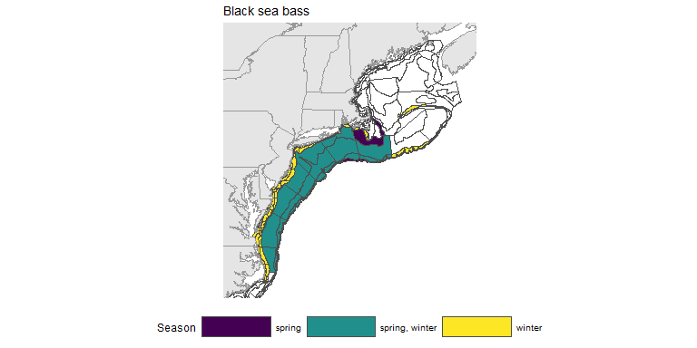

Figure 2.1: Black sea bass distribution

### 2.1.2 Density and distribution estimation

The density of observations for Black sea bass was visualized using two-dimensional kernel density estimation on a grid as documented in MASS::kde2d. This density estimation is then visualized to indicate areas of greater or lesser probability of occurrence.

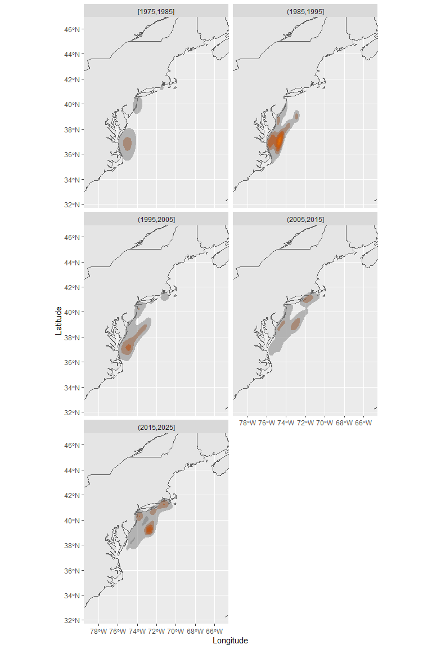

Figure 2.2: Black sea bass density and distribution by decade

### 2.1.3 Centroid of observations

The unweighted centroid is one metric that describes the geometric center of the observed range of Black sea bass in a given year. Calculated as the mean of latitude and longitude of all survey tows that captured the species of interest.

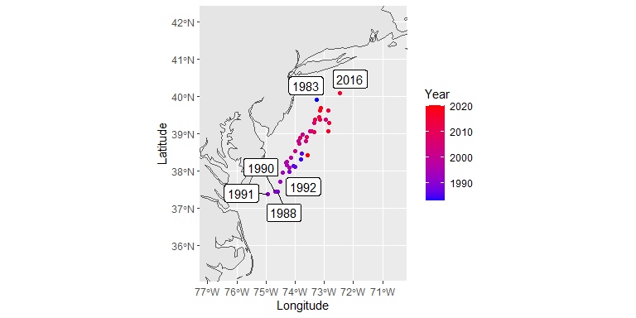

Figure 2.3: Black sea bass centroid over time

### 2.1.4 Latitude and longitude ranges

Latitude and longitude ranges were calculated from NOAA/EDAB ECSA [seasonal species strata](https://github.com/NOAA-EDAB/ECSA/blob/master/data/seasonal_stock_strata.csv) and [Bottom Trawl Survey (BTS) shapefiles](https://github.com/NOAA-EDAB/ECSA/tree/master/data/strata_shapefiles). The coordinate system is WGS84.

|  |  |  |  |  |  |  |
| --- | --- | --- | --- | --- | --- | --- |
| Region | Season | Lat_min | Long_min | Lat_max | Long_max | Warning |
| all | spring | -75.66 | 35.5 | -68.79 | 42.03 | none |
| all | winter | -76.07 | 35.14 | -65.94 | 42.24 | shapefile is missing some strata data |

## 2.2 Temperature

Surface and bottom temperature data were pulled from survdat.

### 2.2.1 Figures

Separate geom_gls() functions were fit for fall and spring measurements; trend lines are only shown when the trend was statistically significant, so some plots may have fewer than two trend lines. Fall has solid trend lines, and spring has dashed trend lines. Please note, sometimes the survey observed a small number of fish outside of the defined stock area.

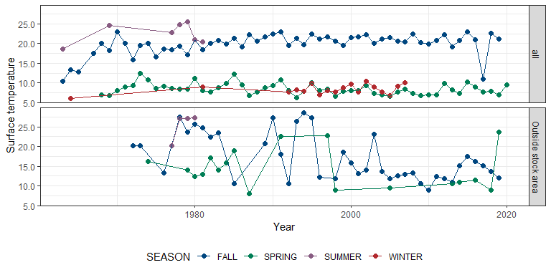

Figure 2.4: Black sea bass surface temperature

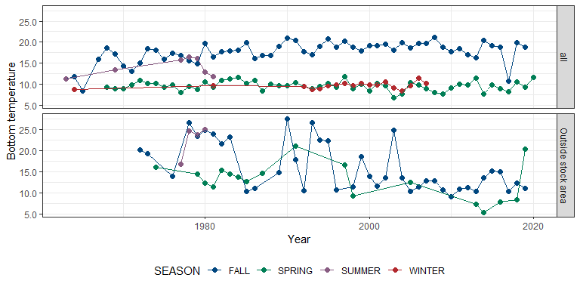

Figure 2.5: Black sea bass bottom temperature

### 2.2.2 Summary

|  |  |  |  |  |  |  |  |  |  |  |
| --- | --- | --- | --- | --- | --- | --- | --- | --- | --- | --- |
| Season | Region | Total years | Mean | Standard deviation | Minimum | Maximum | Mean (past 5 years) | Standard deviation (past 5 years) | Minimum (past 5 years) | Maximum (past 5 years) |
| FALL | all | 56 | 19.86 | 2.74 | 10.45 | 22.98 | 19.76 | 4.96 | 11.01 | 22.94 |
| FALL | Outside stock area | 40 | 17.17 | 5.90 | 8.88 | 28.63 | 14.91 | 2.15 | 11.96 | 17.46 |
| SPRING | all | 53 | 8.47 | 1.41 | 6.26 | 12.54 | 8.26 | 1.01 | 7.06 | 9.60 |
| SPRING | Outside stock area | 18 | 14.38 | 4.98 | 8.10 | 23.69 | 14.64 | 7.94 | 8.85 | 23.69 |
| SUMMER | all | 7 | 22.56 | 2.58 | 18.65 | 25.46 | 22.93 | 2.21 | 20.48 | 25.46 |
| SUMMER | Outside stock area | 4 | 25.44 | 3.51 | 20.18 | 27.30 | 25.44 | 3.51 | 20.18 | 27.30 |
| WINTER | all | 18 | 8.43 | 1.19 | 6.10 | 10.38 | 8.58 | 1.27 | 6.89 | 10.16 |

|  |  |  |  |  |  |  |  |  |  |  |
| --- | --- | --- | --- | --- | --- | --- | --- | --- | --- | --- |
| Season | Region | Total years | Mean | Standard deviation | Minimum | Maximum | Mean (past 5 years) | Standard deviation (past 5 years) | Minimum (past 5 years) | Maximum (past 5 years) |
| FALL | all | 56 | 17.59 | 2.61 | 8.50 | 21.22 | 17.46 | 3.78 | 10.74 | 19.82 |
| FALL | Outside stock area | 41 | 16.00 | 5.75 | 9.07 | 27.60 | 12.80 | 2.21 | 10.37 | 15.14 |
| SPRING | all | 53 | 9.63 | 1.10 | 6.76 | 11.86 | 9.77 | 1.34 | 8.26 | 11.65 |
| SPRING | Outside stock area | 18 | 12.99 | 4.26 | 5.40 | 21.00 | 12.16 | 7.07 | 7.75 | 20.31 |
| SUMMER | all | 7 | 13.99 | 2.18 | 11.30 | 16.56 | 14.66 | 2.16 | 11.83 | 16.56 |
| SUMMER | Outside stock area | 4 | 22.51 | 3.87 | 16.76 | 24.97 | 22.51 | 3.87 | 16.76 | 24.97 |
| WINTER | all | 18 | 9.72 | 0.72 | 8.43 | 11.47 | 9.81 | 1.14 | 8.43 | 11.47 |

### 2.2.3 Data

## [1] "More than 60 rows of data! Please see `data` folder."

## 2.3 Salinity

Surface and bottom salinity data were pulled from survdat.

### 2.3.1 Figures

Separate geom_gls() functions were fit for fall and spring measurements; trend lines are only shown when the trend was statistically significant, so some plots may have fewer than two trend lines. Fall has solid trend lines, and spring has dashed trend lines. Please note, sometimes the survey observed a small number of fish outside of the defined stock area.

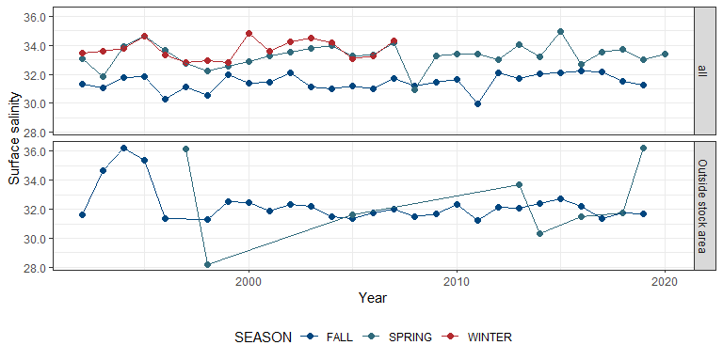

Figure 2.6: Black sea bass surface salinity

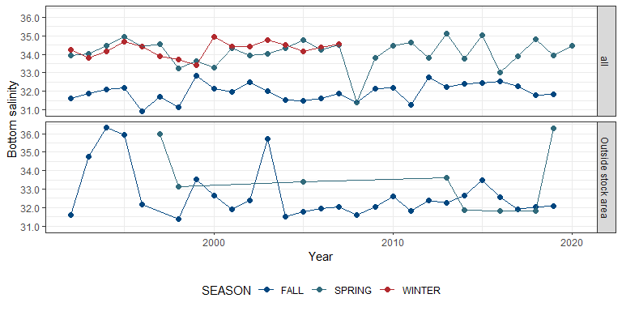

Figure 2.7: Black sea bass bottom salinity

### 2.3.2 Summary

|  |  |  |  |  |  |  |  |  |  |  |
| --- | --- | --- | --- | --- | --- | --- | --- | --- | --- | --- |
| Season | Region | Total years | Mean | Standard deviation | Minimum | Maximum | Mean (past 5 years) | Standard deviation (past 5 years) | Minimum (past 5 years) | Maximum (past 5 years) |
| FALL | all | 28 | 31.44 | 0.57 | 29.98 | 32.23 | 31.86 | 0.44 | 31.28 | 32.23 |
| FALL | Outside stock area | 27 | 32.28 | 1.23 | 31.24 | 36.25 | 31.95 | 0.52 | 31.37 | 32.71 |
| SPRING | all | 29 | 33.28 | 0.80 | 30.91 | 34.92 | 33.26 | 0.42 | 32.68 | 33.70 |
| SPRING | Outside stock area | 8 | 32.44 | 2.78 | 28.22 | 36.23 | 33.16 | 2.67 | 31.47 | 36.23 |
| WINTER | all | 16 | 33.71 | 0.66 | 32.79 | 34.80 | 33.86 | 0.64 | 33.05 | 34.48 |

|  |  |  |  |  |  |  |  |  |  |  |
| --- | --- | --- | --- | --- | --- | --- | --- | --- | --- | --- |
| Season | Region | Total years | Mean | Standard deviation | Minimum | Maximum | Mean (past 5 years) | Standard deviation (past 5 years) | Minimum (past 5 years) | Maximum (past 5 years) |
| FALL | all | 28 | 31.95 | 0.48 | 30.91 | 32.83 | 32.17 | 0.35 | 31.78 | 32.52 |
| FALL | Outside stock area | 27 | 32.70 | 1.39 | 31.36 | 36.36 | 32.40 | 0.64 | 31.91 | 33.46 |
| SPRING | all | 29 | 34.11 | 0.74 | 31.41 | 35.14 | 34.04 | 0.68 | 33.03 | 34.84 |
| SPRING | Outside stock area | 8 | 33.49 | 1.79 | 31.81 | 36.27 | 33.30 | 2.57 | 31.81 | 36.27 |
| WINTER | all | 16 | 34.28 | 0.41 | 33.42 | 34.97 | 34.47 | 0.22 | 34.17 | 34.77 |

### 2.3.3 Data

## [1] "More than 60 rows of data! Please see `data` folder."

## 2.4 Depth

The range of depths that a species occupies is linked to many other habitat characteristics such as benthic structure, food availability, or temperature. Thus, observed depth can signal changes in habitat suitability. Changes in this metric can indicate the required resources are changing their distribution on the landscape. Seasonal differences in occurrence can also help identify essential habitat and the timing of migration to acquire seasonal resources.

### 2.4.1 Figures

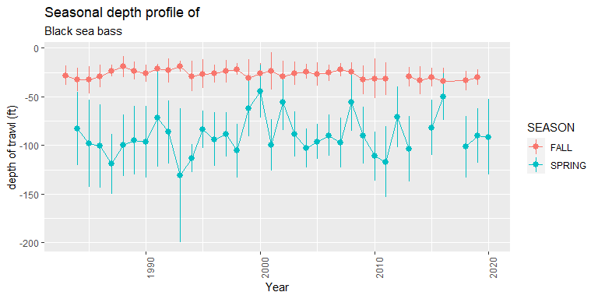

Figure 2.8: Black sea bass depth

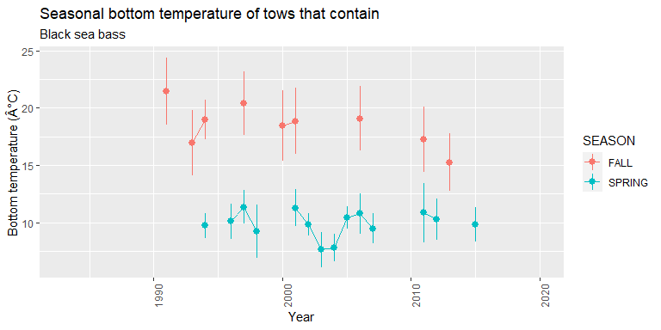

Figure 2.9: Black sea bass temperature at depth

## 2.5 Habitat vulnerability

Habitat vulnerability information is sourced from the ecodata package.

|  |  |  |  |  |  |  |  |
| --- | --- | --- | --- | --- | --- | --- | --- |
| EPU | Habitat name | Habitat vulnerability | Importance of habitat to eggs/larvae | Importance of habitat to juveniles/YOY | Importance of habitat to adults | Importance of habitat to spawning adults | Overall species vulnerability |
| MAB | Marine/estuarine intertidal shellfish reef | Very high | NA | High | High | NA | High |
| MAB | Marine/estuarine subtidal shellfish reef | High | NA | High | High | NA | High |
| MAB | Marine/estuarine submerged aquatic vegetation | High | NA | High | NA | NA | High |
| MAB | Marine intertidal rocky bottom | High | NA | High | High | NA | High |
| NE | New England native salt marsh | Very high | NA | Moderate | NA | NA | High |
| NE | Marine/estuarine intertidal shellfish reef | Very high | NA | Moderate | Moderate | NA | High |

# 3 Biological information

## 3.1 Length

Length data were pulled from survdat. Only years with more than 10 fish lengths were considered for analysis.

### 3.1.1 Overview

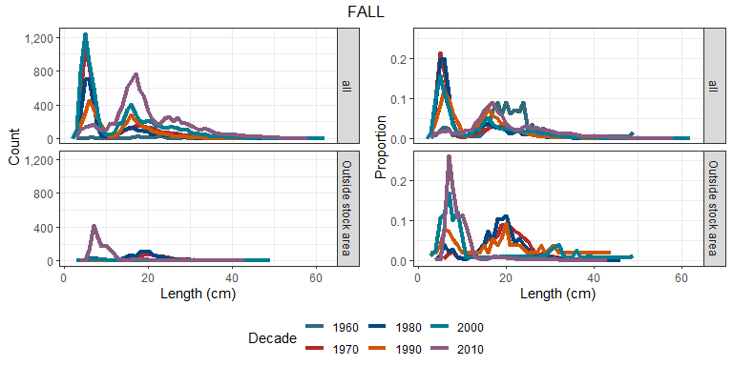

Figure 3.1: Black sea bass length frequency distribution

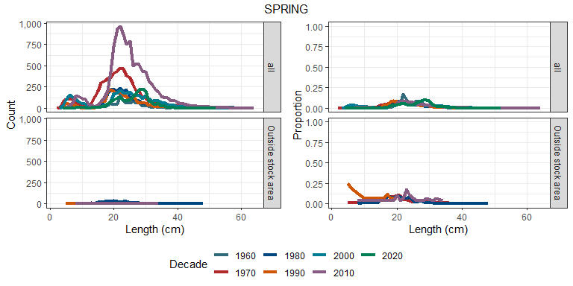

Figure 3.2: Black sea bass length frequency distribution

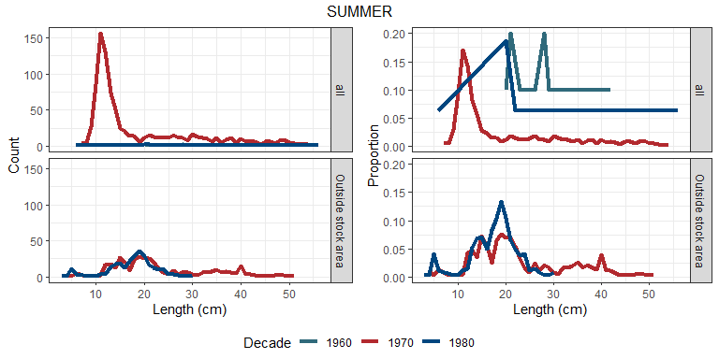

Figure 3.3: Black sea bass length frequency distribution

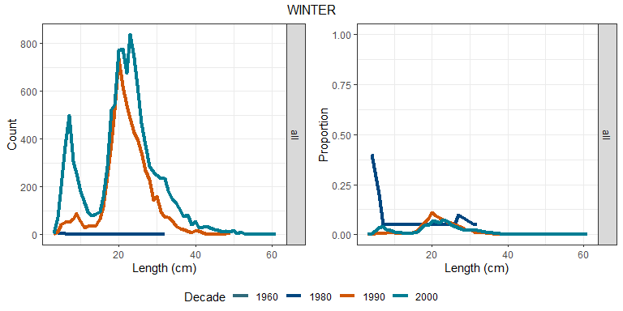

Figure 3.4: Black sea bass length frequency distribution

### 3.1.2 Summary statistics

Separate geom_gls() functions were fit for the minimum, mean, and maximum lengths; trend lines are only shown when the trend was statistically significant, so some plots may have fewer than three trend lines. Please note, sometimes the survey observed a small number of fish outside of the defined stock area.

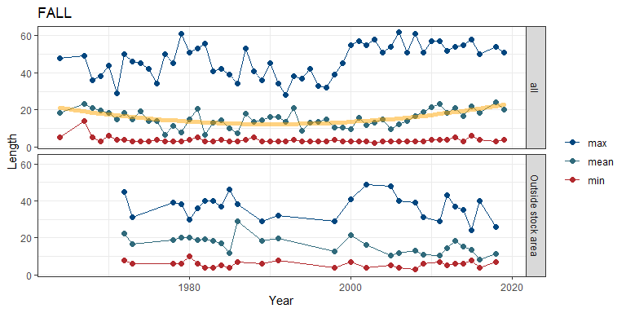

Figure 3.5: Black sea bass length

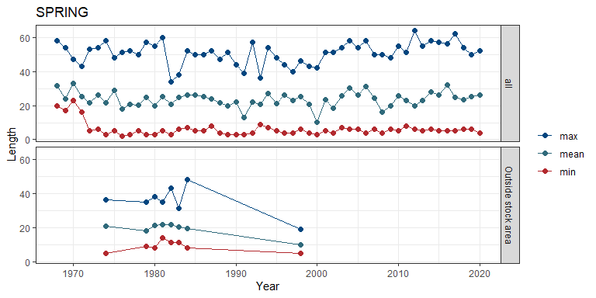

Figure 3.6: Black sea bass length

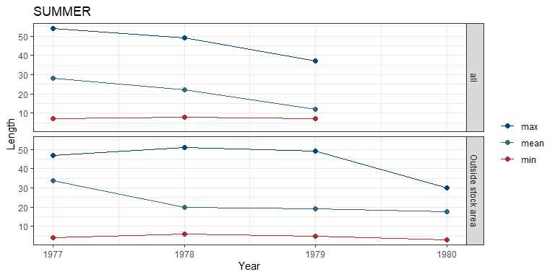

Figure 3.7: Black sea bass length

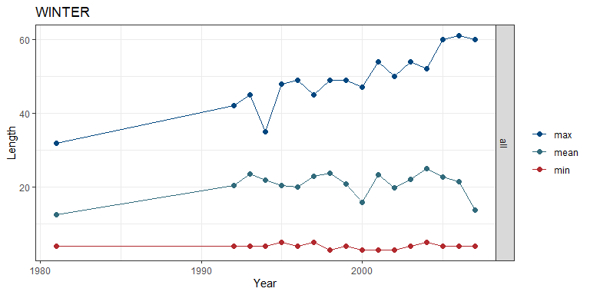

Figure 3.8: Black sea bass length

### 3.1.3 Risk

See Methods for risk calculation details.

##### Rank of change compared to historical, ranked among stocks

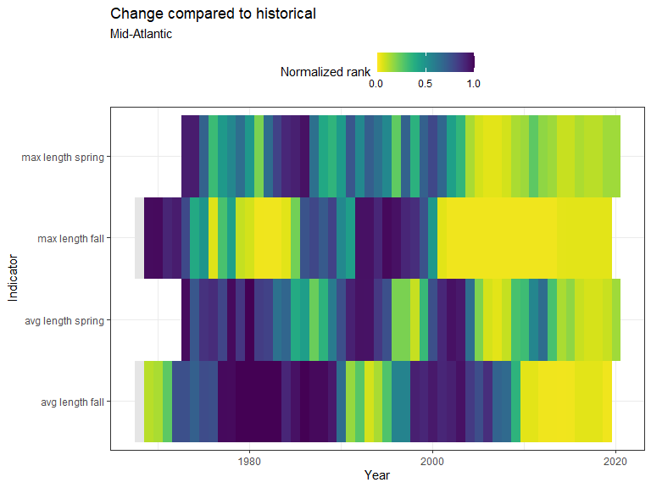

Figure 3.9: Black sea bass rank of change in indicator compared to historical, ranked among stocks

##### Rank of value (magnitude) in each year, compared to other stocks

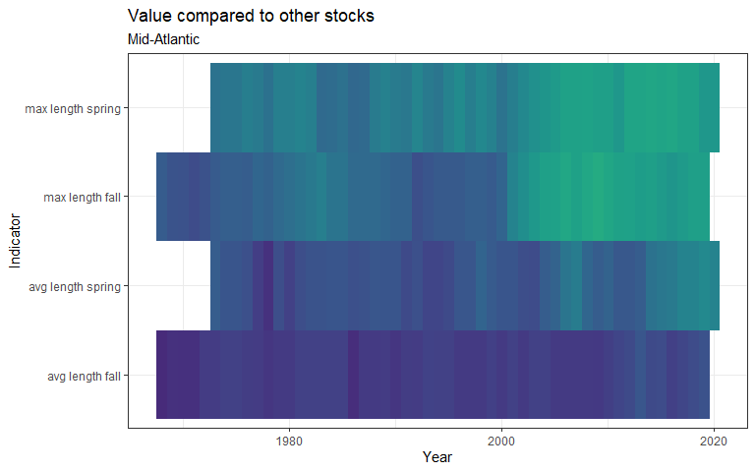

Figure 3.10: Black sea bass rank of value (magnitude) in each year, compared to other stocks

##### Rank of value (magnitude) within a single stock, compared to all years

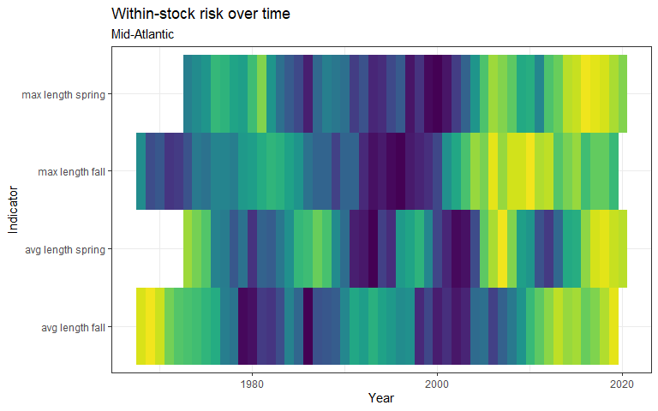

Figure 3.11: Black sea bass rank of value (magnitude) within a single stock, compared to all years

### 3.1.4 Summary

|  |  |  |  |  |  |
| --- | --- | --- | --- | --- | --- |
| Season | Region | Mean value +- SD (n fish, n years) | Mean value +- SD (n fish, past 5 years) | Range (total) | Range (past 5 years) |
| FALL | all | 14.59 +- 9.36 (28,922, 53) | 20.92 +- 8.62 (4,060, 4) | 2 - 62 | 3 - 58 |
| FALL | Outside stock area | 15.07 +- 7.83 (3,519, 27) | 9.35 +- 4.12 (1,387, 4) | 3 - 49 | 4 - 40 |
| SPRING | all | 23.64 +- 7.81 (29,155, 53) | 25.53 +- 6.44 (7,558, 5) | 2 - 64 | 4 - 62 |
| SPRING | Outside stock area | 20.39 +- 5.58 (498, 8) | 9.67 +- 5.31 (12, 1) | 5 - 48 | 5 - 19 |
| SUMMER | all | 19.04 +- 11.32 (915, 3) | 19.04 +- 11.32 (915, 3) | 7 - 54 | 7 - 54 |
| SUMMER | Outside stock area | 20.5 +- 8.14 (639, 4) | 20.5 +- 8.14 (639, 4) | 3 - 51 | 3 - 51 |
| WINTER | all | 21.7 +- 7.95 (18,156, 17) | 22.09 +- 8.26 (7,441, 5) | 3 - 61 | 4 - 61 |

### 3.1.5 Data

## [1] "More than 60 rows of data! Please see `data` folder."

## 3.2 von Bertalanffy growth curve

### 3.2.1 Length at age growth curve

The predicted von Bertalanffy growth curve for NMFS managed fish species. Growth parameters of Linf (Length infinty), K (growth coefficient), and t0 (size at time 0) were estimated using non-linear least square model. The starting point for model building is accomplished using FSA::vbStarts. Age and length data sourced from survdat and spans all years and survey areas.

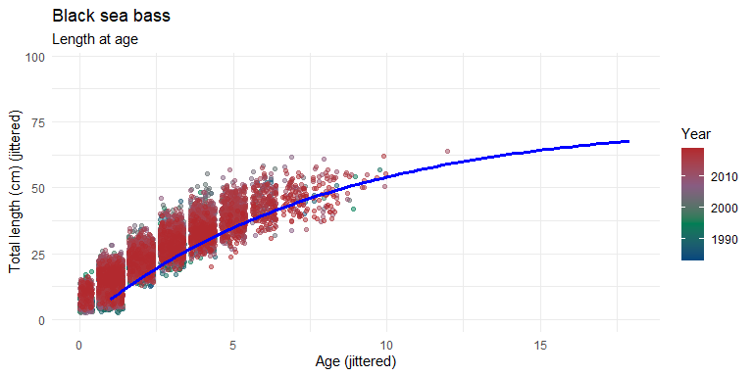

Figure 3.12: Black sea bass length at age growth curve

## 3.3 Length at first maturity

### 3.3.1 Size at first maturity

L50 or length at which 50% maturity can be calculated using differing methods. Using Data sourced from survdat that consist of visual sexual maturity determination and length measurements. Here, L50 is estimated by fitting a logistic generalized linear model to gonadal maturity and body length measurements and estimating the inflection point of the logistic model. This point represents the size where the individual has 50% odds of being mature. Decade variations of this parameter are investigated utilizing decade as a additive and interaction term in the model specification.

The relationship between sexual maturity by body size is a well established life history parameter. L50 is a useful metric in fisheries to identify sizes that are able to reproduce. This information can be used to inform regulation as to minimum catch size that should allow for a significant portion of the population to spawn and contribute genetic information to sustain the stock. Changes in this parameter can signal population/evolutionary pressures on the stock with reduction in this size potentially indicating excessive fishing pressure.

### 3.3.2 Maturity classification

The gonadal development stage can vary between immature and mature. Once mature, there are several stages that represent phases in the spawning sequence. These stages and phases can vary across body length and the proportion of the population in each of these categories can help identify spawning size and what seasonal effects there are on development.

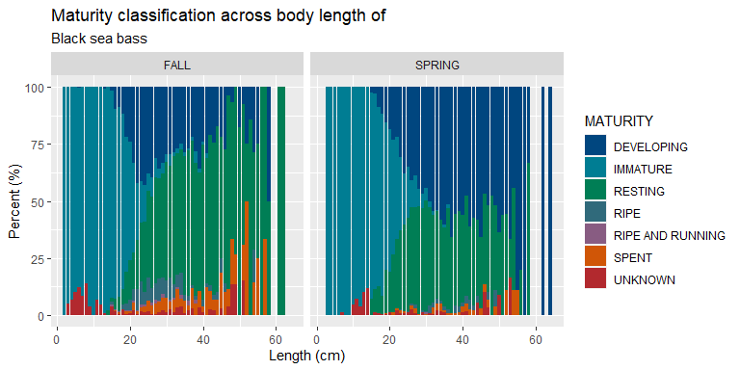

Figure 3.13: Black sea bass maturity classification

### 3.3.3 Model results

If the overall model is significant, there is support for the relationship between sexual maturity and body size. This model can predict the size where there are 50% odds of the indevidual is sexually mature. The results table below displays the L50 for Male and female indeviduals.

|  |  |  |  |  |  |  |  |  |
| --- | --- | --- | --- | --- | --- | --- | --- | --- |
|  | Estimate | Odds Ratio | CI (lower) | CI (upper) | Std. Error | z value | Pr(>|z|) |  |
| (Intercept) | -7.895 | 0.000 | 0.000 | 0.001 | 0.207 | -38.158 | <0.001 | *** |
| LENGTH | 0.369 | 1.447 | 1.421 | 1.474 | 0.009 | 39.434 | <0.001 | *** |
| SEX: male | 1.114 | 3.047 | 1.308 | 6.895 | 0.424 | 2.629 | 0.009 | ** |
| LENGTH:SEXmale | -0.001 | 0.999 | 0.961 | 1.040 | 0.020 | -0.059 | 0.953 |  |

### 3.3.4 L50 differences between sexes

The significance of differences between sex can be determined by referencing the model summary table above differences in intercept indicate differences in mean size between groups. Differences in betta coefficents indicate increases or decreases to the degree to which probability of maturity increases across body lengths

|  |  |  |
| --- | --- | --- |
|  | Female | Male |
| Length (cm) at 50% maturity | 21.378 | 18.421 |

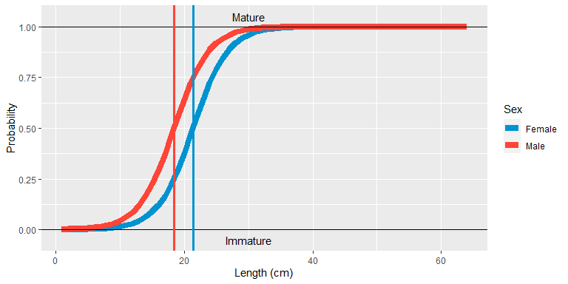

Figure 3.14: Black sea bass probability of maturity

## 3.4 Condition

Condition information comes from [diet data](https://github.com/Laurels1/Condition/blob/master/data/allfh.RData); only regions and seasons with more than 10 fish observations were considered. We calculated a rough condition factor as: Weight / Length^3, and relative weight was [previously calculated](https://github.com/Laurels1/Condition/tree/master/data).

### 3.4.1 Length vs weight

Please note, no trend lines were fit, points are jittered to reduce overlap, and sometimes the survey observed a small number of fish outside of the defined stock area.

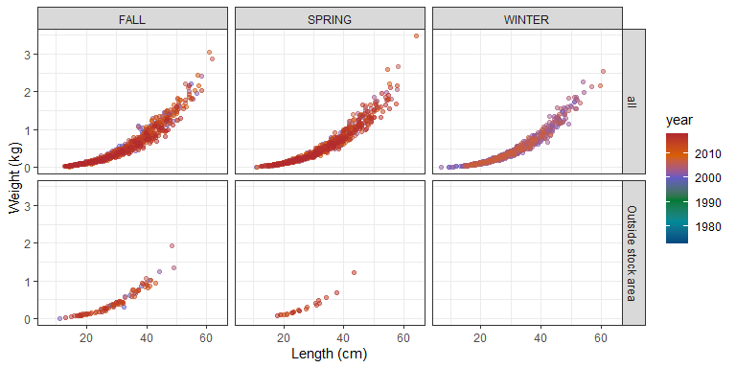

Figure 3.15: Black sea bass length vs weight

### 3.4.2 Condition factor: Weight-volume

If there were more than 30 years of data, a geom_gls() regression was fit. In order to fit the geom_gls() regression, we calculated the mean condition factor for each year and plotted the geom_gls() through those points. Please note, points are jittered to reduce overlap, and sometimes the survey observed a small number of fish outside of the defined stock area.

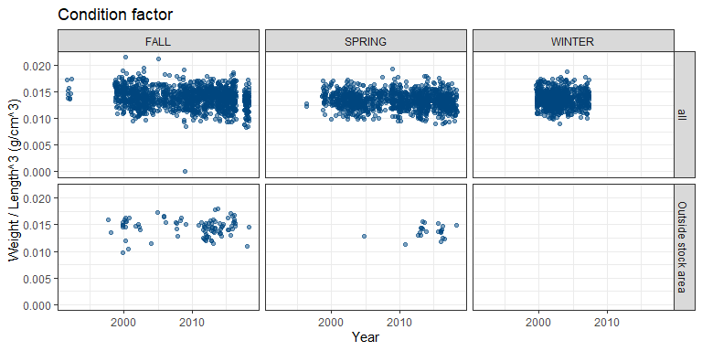

Figure 3.16: Black sea bass weight-volume condition

#### 3.4.2.1 Condition factor: Relative weight

Please note, this data is aggregated by Ecological Protection Unit (EPU), which may differ slightly from the stock assessment regions.

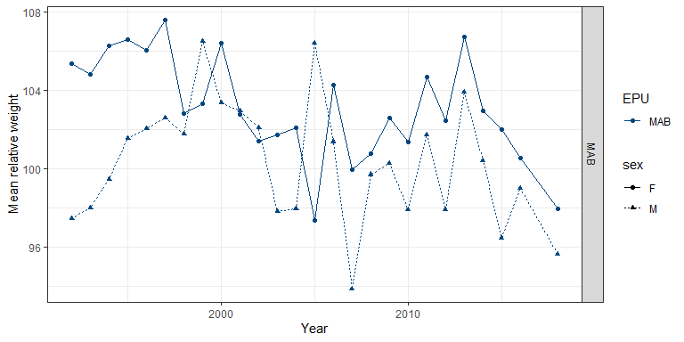

Figure 3.17: Black sea bass relative weight

### 3.4.3 Data

#### Length vs weight with weight-volume condition factor

## [1] "More than 60 rows of data! Please see `data` folder."

#### Relative weight condition factor

Please note, this data is aggregated by Ecological Protection Unit (EPU), which may differ slightly from the stock assessment regions.

|  |  |  |  |  |
| --- | --- | --- | --- | --- |
| EPU | Fish sex | Year | Mean condition | Number of fish |
| MAB | F | 1992 | 105.4 | 41 |
| MAB | F | 1993 | 104.8 | 23 |
| MAB | F | 1994 | 106.3 | 21 |
| MAB | F | 1995 | 106.6 | 39 |
| MAB | F | 1996 | 106.1 | 22 |
| MAB | F | 1997 | 107.6 | 38 |
| MAB | F | 1998 | 102.8 | 36 |
| MAB | F | 1999 | 103.3 | 29 |
| MAB | F | 2000 | 106.4 | 53 |
| MAB | F | 2001 | 102.8 | 52 |
| MAB | F | 2002 | 101.4 | 86 |
| MAB | F | 2003 | 101.7 | 71 |
| MAB | F | 2004 | 102.1 | 40 |
| MAB | F | 2005 | 97.3 | 18 |
| MAB | F | 2006 | 104.2 | 23 |
| MAB | F | 2007 | 99.9 | 48 |
| MAB | F | 2008 | 100.7 | 31 |
| MAB | F | 2009 | 102.6 | 130 |
| MAB | F | 2010 | 101.4 | 96 |
| MAB | F | 2011 | 104.7 | 109 |
| MAB | F | 2012 | 102.4 | 213 |
| MAB | F | 2013 | 106.7 | 91 |
| MAB | F | 2014 | 102.9 | 130 |
| MAB | F | 2015 | 102.0 | 190 |
| MAB | F | 2016 | 100.5 | 131 |
| MAB | F | 2018 | 97.9 | 161 |
| MAB | M | 1992 | 97.5 | 9 |
| MAB | M | 1993 | 98.0 | 14 |
| MAB | M | 1994 | 99.4 | 14 |
| MAB | M | 1995 | 101.5 | 19 |
| MAB | M | 1996 | 102.1 | 15 |
| MAB | M | 1997 | 102.6 | 18 |
| MAB | M | 1998 | 101.8 | 14 |
| MAB | M | 1999 | 106.5 | 6 |
| MAB | M | 2000 | 103.4 | 28 |
| MAB | M | 2001 | 102.9 | 19 |
| MAB | M | 2002 | 102.1 | 38 |
| MAB | M | 2003 | 97.8 | 49 |
| MAB | M | 2004 | 97.9 | 20 |
| MAB | M | 2005 | 106.4 | 8 |
| MAB | M | 2006 | 101.4 | 10 |
| MAB | M | 2007 | 93.8 | 9 |
| MAB | M | 2008 | 99.7 | 18 |
| MAB | M | 2009 | 100.3 | 70 |
| MAB | M | 2010 | 97.9 | 39 |
| MAB | M | 2011 | 101.7 | 34 |
| MAB | M | 2012 | 97.9 | 37 |
| MAB | M | 2013 | 103.9 | 46 |
| MAB | M | 2014 | 100.4 | 62 |
| MAB | M | 2015 | 96.4 | 93 |
| MAB | M | 2016 | 99.0 | 45 |
| MAB | M | 2018 | 95.6 | 60 |

## 3.5 Diet

Diet data were compiled from [existing data](https://github.com/Laurels1/Condition/blob/master/data/allfh.RData). For analysis, all geographic samples were grouped by season, year, and region, and only year-season-region combinations with more than 20 predators sampled were considered. Prey items that made up more than 5% of the predator’s diet in at least one year-season-region were identified to the broad category level; all other prey are grouped into the “other” category.

### 3.5.1 Figure

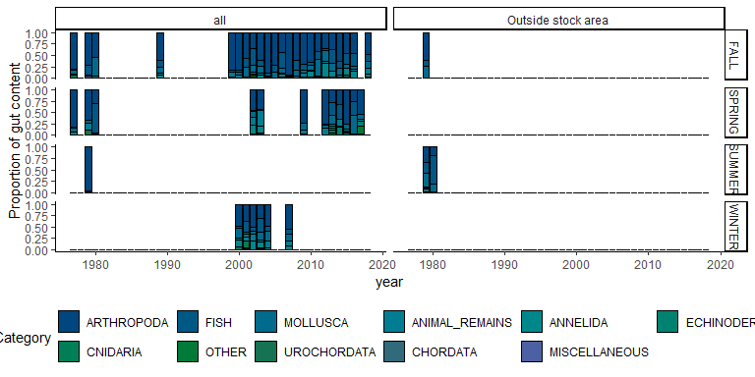

Figure 3.18: Black sea bass diet composition

### 3.5.2 Summary

|  |  |  |  |  |
| --- | --- | --- | --- | --- |
| Prey category | Season | Region | Mean proportion +- SD (n years) | Range |
| ANIMAL_REMAINS | FALL | all | 0.033 +- 0.032 (23) | 0.004 - 0.126 |
| ANIMAL_REMAINS | FALL | Outside stock area | 0.003 +- NA (1) | 0.003 - 0.003 |
| ANIMAL_REMAINS | SPRING | all | 0.101 +- 0.098 (12) | 0 - 0.334 |
| ANIMAL_REMAINS | SUMMER | all | 0.013 +- NA (1) | 0.013 - 0.013 |
| ANIMAL_REMAINS | SUMMER | Outside stock area | 0.007 +- 0.005 (2) | 0.004 - 0.01 |
| ANIMAL_REMAINS | WINTER | all | 0.091 +- 0.055 (6) | 0.03 - 0.16 |
| ANNELIDA | FALL | all | 0.071 +- 0.078 (19) | 0.002 - 0.316 |
| ANNELIDA | FALL | Outside stock area | 0.001 +- NA (1) | 0.001 - 0.001 |
| ANNELIDA | SPRING | all | 0.042 +- 0.063 (12) | 0 - 0.179 |
| ANNELIDA | SUMMER | all | 0.014 +- NA (1) | 0.014 - 0.014 |
| ANNELIDA | SUMMER | Outside stock area | 0 +- 0 (2) | 0 - 0.001 |
| ANNELIDA | WINTER | all | 0.115 +- 0.057 (6) | 0.04 - 0.196 |
| ARTHROPODA | FALL | all | 0.606 +- 0.175 (23) | 0.347 - 0.932 |
| ARTHROPODA | FALL | Outside stock area | 0.6 +- NA (1) | 0.6 - 0.6 |
| ARTHROPODA | SPRING | all | 0.524 +- 0.211 (12) | 0.261 - 0.819 |
| ARTHROPODA | SUMMER | all | 0.965 +- NA (1) | 0.965 - 0.965 |
| ARTHROPODA | SUMMER | Outside stock area | 0.257 +- 0.101 (2) | 0.186 - 0.328 |
| ARTHROPODA | WINTER | all | 0.449 +- 0.085 (6) | 0.318 - 0.554 |
| CHORDATA | SUMMER | Outside stock area | 0.077 +- NA (1) | 0.077 - 0.077 |
| CNIDARIA | FALL | all | 0.014 +- 0.017 (7) | 0 - 0.048 |
| CNIDARIA | SPRING | all | 0.033 +- 0.031 (4) | 0.005 - 0.062 |
| CNIDARIA | SUMMER | Outside stock area | 0.013 +- NA (1) | 0.013 - 0.013 |
| CNIDARIA | WINTER | all | 0.093 +- 0.102 (2) | 0.02 - 0.165 |
| ECHINODERMATA | FALL | all | 0.009 +- 0.012 (5) | 0.002 - 0.03 |
| ECHINODERMATA | SPRING | all | 0.04 +- 0.061 (11) | 0 - 0.192 |
| ECHINODERMATA | SUMMER | Outside stock area | 0.008 +- 0.01 (2) | 0.001 - 0.014 |
| ECHINODERMATA | WINTER | all | 0.004 +- 0.002 (3) | 0.002 - 0.006 |
| FISH | FALL | all | 0.158 +- 0.102 (22) | 0.017 - 0.355 |
| FISH | FALL | Outside stock area | 0.147 +- NA (1) | 0.147 - 0.147 |
| FISH | SPRING | all | 0.168 +- 0.219 (10) | 0.006 - 0.657 |
| FISH | SUMMER | all | 0.001 +- NA (1) | 0.001 - 0.001 |
| FISH | SUMMER | Outside stock area | 0.436 +- 0.275 (2) | 0.242 - 0.63 |
| FISH | WINTER | all | 0.149 +- 0.093 (6) | 0.046 - 0.294 |
| MISCELLANEOUS | FALL | all | 0.014 +- 0.016 (10) | 0.001 - 0.051 |
| MISCELLANEOUS | SPRING | all | 0.008 +- 0.006 (4) | 0 - 0.016 |
| MISCELLANEOUS | SUMMER | all | 0.001 +- NA (1) | 0.001 - 0.001 |
| MISCELLANEOUS | SUMMER | Outside stock area | 0.009 +- 0.002 (2) | 0.008 - 0.011 |
| MISCELLANEOUS | WINTER | all | 0.002 +- NA (1) | 0.002 - 0.002 |
| MOLLUSCA | FALL | all | 0.131 +- 0.1 (23) | 0.004 - 0.407 |
| MOLLUSCA | FALL | Outside stock area | 0.248 +- NA (1) | 0.248 - 0.248 |
| MOLLUSCA | SPRING | all | 0.146 +- 0.103 (9) | 0.076 - 0.402 |
| MOLLUSCA | SUMMER | all | 0.006 +- NA (1) | 0.006 - 0.006 |
| MOLLUSCA | SUMMER | Outside stock area | 0.235 +- 0.107 (2) | 0.16 - 0.311 |
| MOLLUSCA | WINTER | all | 0.143 +- 0.081 (6) | 0.037 - 0.221 |
| OTHER | FALL | all | 0.012 +- 0.013 (13) | 0 - 0.045 |
| OTHER | FALL | Outside stock area | 0.001 +- NA (1) | 0.001 - 0.001 |
| OTHER | SPRING | all | 0.038 +- 0.058 (7) | 0.001 - 0.159 |
| OTHER | SUMMER | Outside stock area | 0.001 +- 0 (2) | 0.001 - 0.002 |
| OTHER | WINTER | all | 0.009 +- 0.01 (2) | 0.002 - 0.016 |
| UROCHORDATA | FALL | all | 0.011 +- 0.005 (2) | 0.007 - 0.014 |
| UROCHORDATA | SPRING | all | 0.067 +- 0.041 (2) | 0.038 - 0.095 |
| UROCHORDATA | WINTER | all | 0.032 +- 0.031 (3) | 0.01 - 0.067 |

### 3.5.3 Data

## [1] "More than 60 rows of data! Please see `data` folder."

# 4 Population information

## 4.1 Abundance

Abundance data were pulled from survdat and assessmentdata::stockAssessmentData.

### 4.1.1 Survey abundance (raw measurements)

Separate geom_gls() functions were fit for fall and spring measurements; trend lines are only shown when the trend was statistically significant, so some plots may have fewer than two trend lines. Fall has solid trend lines, and spring has dashed trend lines. Please note, sometimes the survey observed a small number of fish outside of the defined stock area.

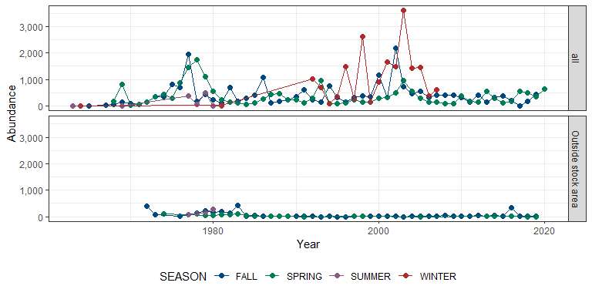

Figure 4.1: Black sea bass survey abundance

#### Risk

See Methods for risk calculation details.

##### Rank of change compared to historical, ranked among stocks

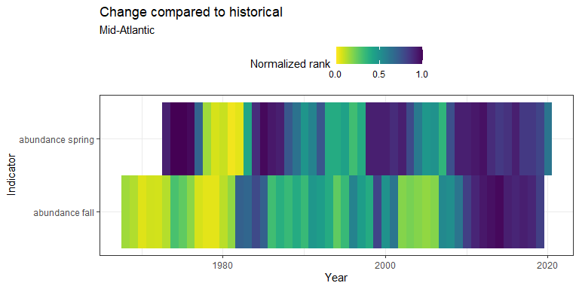

Figure 4.2: Black sea bass rank of change in indicator compared to historical, ranked among stocks

##### Rank of value (magnitude) in each year, compared to other stocks

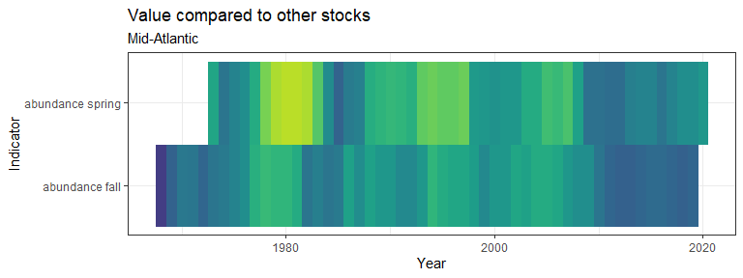

Figure 4.3: Black sea bass rank of value (magnitude) in each year, compared to other stocks

##### Rank of value (magnitude) within a single stock, compared to all years

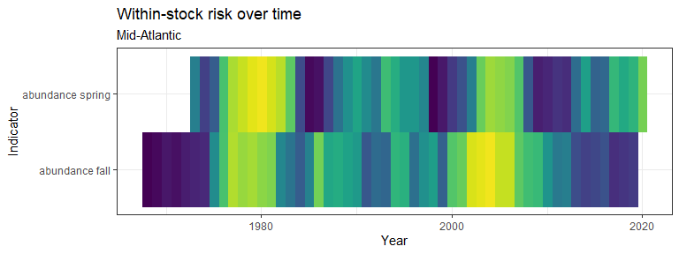

Figure 4.4: Black sea bass rank of value (magnitude) within a single stock, compared to all years

### 4.1.2 Survey abundance (swept area estimates)

Please note, these estimates are not parsed by region Swept area estimates are based on spring and fall surveys only. The shaded gray region indicates +/- two standard errors.

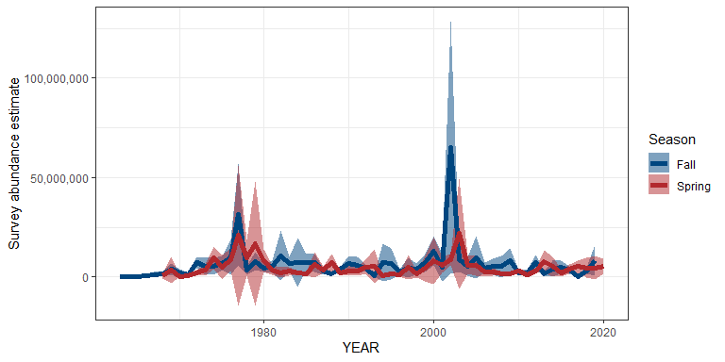

Figure 4.5: Black sea bass swept area estimate from survey abundance

### 4.1.3 Assessment abundance

## [1] "NO DATA"

#### Risk

See Methods for risk calculation details.

##### Rank of change compared to historical, ranked among stocks

## [1] "No Mid-Atlantic data"

##### Rank of value (magnitude) in each year, compared to other stocks

## [1] "No Mid-Atlantic data"

##### Rank of value (magnitude) within a single stock, compared to all years

## [1] "No Mid-Atlantic data"

### 4.1.4 Survey summary

|  |  |  |  |  |  |  |  |  |  |  |
| --- | --- | --- | --- | --- | --- | --- | --- | --- | --- | --- |
| Season | Region | Total years | Mean | Standard deviation | Minimum | Maximum | Mean (past 5 years) | Standard deviation (past 5 years) | Minimum (past 5 years) | Maximum (past 5 years) |
| FALL | all | 56 | 392.27 | 410.62 | 1 | 2182 | 239.60 | 169.32 | 1 | 430 |
| FALL | Outside stock area | 44 | 56.02 | 102.41 | 1 | 427 | 72.80 | 142.34 | 2 | 327 |
| SPRING | all | 53 | 370.75 | 355.50 | 20 | 1747 | 445.60 | 181.69 | 186 | 634 |
| SPRING | Outside stock area | 20 | 26.65 | 35.28 | 1 | 99 | 1.67 | 1.15 | 1 | 3 |
| SUMMER | all | 7 | 134.43 | 207.57 | 3 | 499 | 186.20 | 230.00 | 8 | 499 |
| SUMMER | Outside stock area | 4 | 159.75 | 80.73 | 82 | 267 | 159.75 | 80.73 | 82 | 267 |
| WINTER | all | 18 | 1008.72 | 966.26 | 1 | 3612 | 1488.20 | 1282.09 | 363 | 3612 |

### 4.1.5 Data

#### Survey data (raw measurements)

## [1] "More than 60 rows of data! Please see `data` folder."

#### Survey data (swept area estimates)

## [1] "More than 60 rows of data! Please see `data` folder."

#### Assessment data

## [1] "NO DATA"

## 4.2 Biomass

Biomass data were pulled from survdat.

### 4.2.1 Survey biomass (raw measurements)

Separate geom_gls() functions were fit for fall and spring measurements; trend lines are only shown when the trend was statistically significant, so some plots may have fewer than two trend lines. Fall has solid trend lines, and spring has dashed trend lines. Please note, sometimes the survey observed a small number of fish outside of the defined stock area.

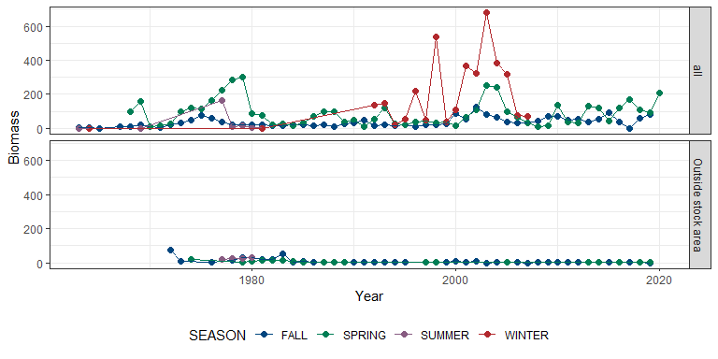

Figure 4.6: Black sea bass survey biomass

#### Risk

See Methods for risk calculation details.

##### Rank of change compared to historical, ranked among stocks

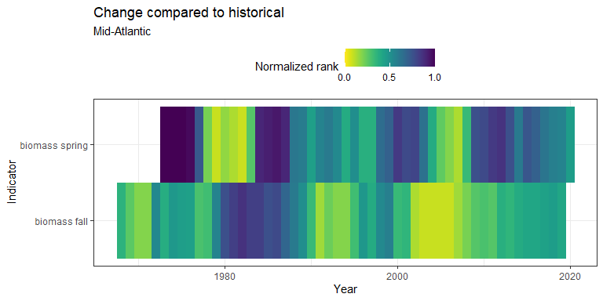

Figure 4.7: Black sea bass rank of change in indicator compared to historical, ranked among stocks

##### Rank of value (magnitude) in each year, compared to other stocks

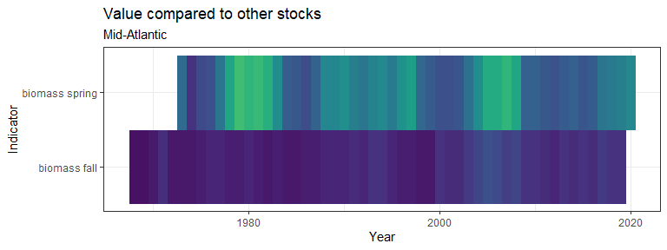

Figure 4.8: Black sea bass rank of value (magnitude) in each year, compared to other stocks

##### Rank of value (magnitude) within a single stock, compared to all years

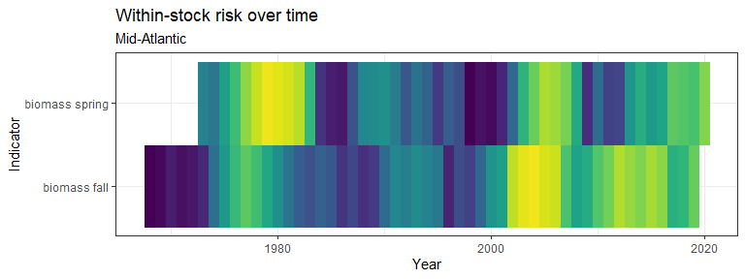

Figure 4.9: Black sea bass rank of value (magnitude) within a single stock, compared to all years

### 4.2.2 Survey biomass (swept area estimates)

Please note, these estimates are not parsed by region or season. Swept area estimates are based on spring and fall surveys only. The shaded gray region indicates +/- two standard errors.

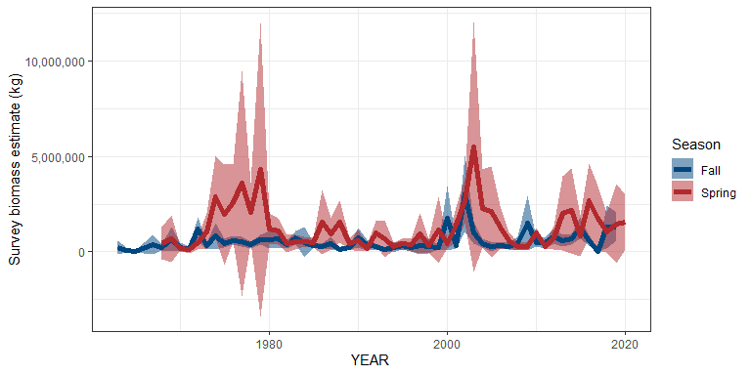

Figure 4.10: Black sea bass swept area estimate from survey biomass

### 4.2.3 Assessment biomass

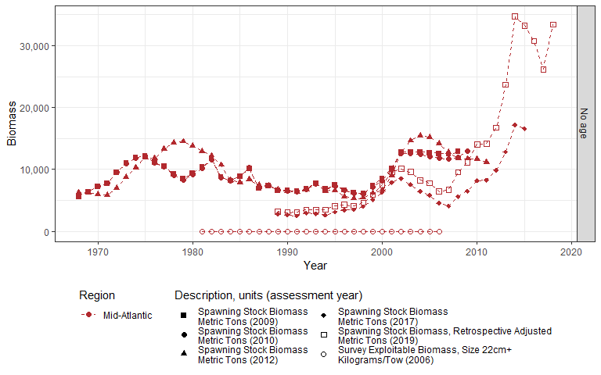

Figure 4.11: Black sea bass assessment biomass

#### Risk

See Methods for risk calculation details.

##### Rank of change compared to historical, ranked among stocks

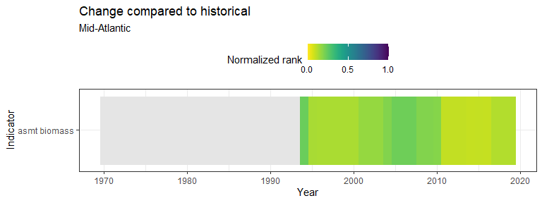

Figure 4.12: Black sea bass rank of change in indicator compared to historical, ranked among stocks

##### Rank of value (magnitude) in each year, compared to other stocks

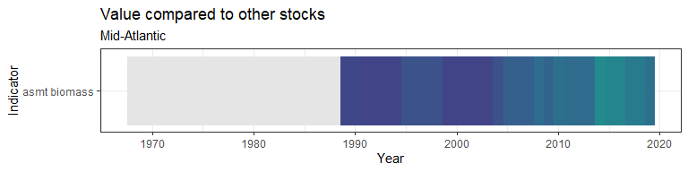

Figure 4.13: Black sea bass rank of value (magnitude) in each year, compared to other stocks

##### Rank of value (magnitude) within a single stock, compared to all years

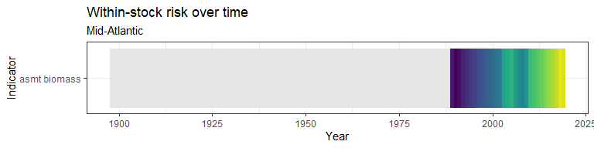

Figure 4.14: Black sea bass rank of value (magnitude) within a single stock, compared to all years

### 4.2.4 Survey summary

|  |  |  |  |  |  |  |  |  |  |  |
| --- | --- | --- | --- | --- | --- | --- | --- | --- | --- | --- |
| Season | Region | Total years | Mean | Standard deviation | Minimum | Maximum | Mean (past 5 years) | Standard deviation (past 5 years) | Minimum (past 5 years) | Maximum (past 5 years) |
| FALL | all | 56 | 35.60 | 26.82 | 0.39 | 127.71 | 53.48 | 35.70 | 0.39 | 90.31 |
| FALL | Outside stock area | 42 | 7.72 | 14.98 | 0.01 | 75.20 | 1.25 | 1.85 | 0.03 | 4.52 |
| SPRING | all | 53 | 89.35 | 73.86 | 9.40 | 302.10 | 139.41 | 47.26 | 94.98 | 207.43 |
| SPRING | Outside stock area | 19 | 4.57 | 6.05 | 0.10 | 17.70 | 0.44 | 0.49 | 0.10 | 1.01 |
| SUMMER | all | 7 | 28.71 | 59.71 | 1.40 | 163.50 | 39.56 | 69.52 | 2.30 | 163.50 |
| SUMMER | Outside stock area | 4 | 22.65 | 4.15 | 17.80 | 27.90 | 22.65 | 4.15 | 17.80 | 27.90 |
| WINTER | all | 18 | 196.25 | 197.62 | 1.40 | 680.04 | 305.73 | 252.14 | 68.74 | 680.04 |

### 4.2.5 Data

#### Survey data (raw measurements)

## [1] "More than 60 rows of data! Please see `data` folder."

#### Survey data (swept area estimates)

## [1] "More than 60 rows of data! Please see `data` folder."

#### Assessment data

## [1] "More than 60 rows of data! Please see `data` folder."

## 4.3 B/Bmsy

B/Bmsy data were pulled from assessmentdata::stockAssessmentSummary.

The most recent status of B/Bmsy is: GOOD

### 4.3.1 Figure

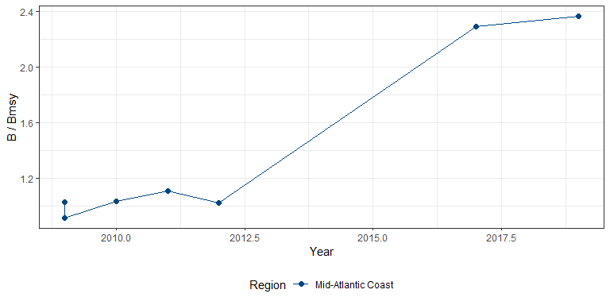

Figure 4.15: Black sea bass B/Bmsy

#### Risk

See Methods for risk calculation details.

##### Rank of change compared to historical, ranked among stocks

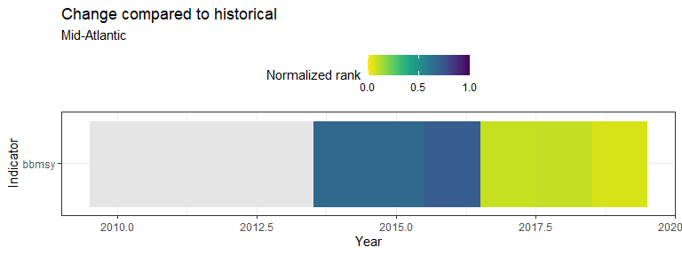

Figure 4.16: Black sea bass rank of change in indicator compared to historical, ranked among stocks

##### Rank of value (magnitude) in each year, compared to other stocks

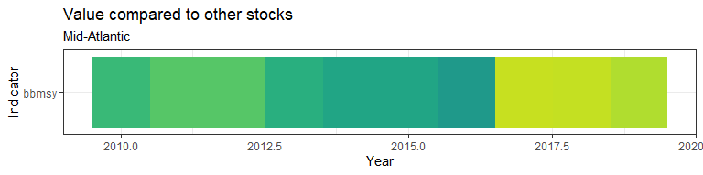

Figure 4.17: Black sea bass rank of value (magnitude) in each year, compared to other stocks

##### Rank of value (magnitude) within a single stock, compared to all years

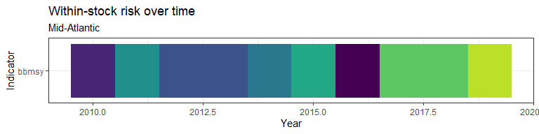

Figure 4.18: Black sea bass rank of value (magnitude) within a single stock, compared to all years

### 4.3.2 Data

|  |  |  |
| --- | --- | --- |
| Region | Year | B/Bmsy |
| Mid-Atlantic Coast | 2009 | 1.03 |
| Mid-Atlantic Coast | 2009 | 0.92 |
| Mid-Atlantic Coast | 2010 | 1.03 |
| Mid-Atlantic Coast | 2011 | 1.11 |
| Mid-Atlantic Coast | 2012 | 1.02 |
| Mid-Atlantic Coast | 2017 | 2.29 |
| Mid-Atlantic Coast | 2019 | 2.37 |

## 4.4 Recruitment

Recruitment data were pulled from assessmentdata::stockAssessmentData. Separate geom_gls() functions were fit for each region; trend lines are only shown when the trend was statistically significant, so some plots may have fewer trend lines than regions.

### 4.4.1 Figure

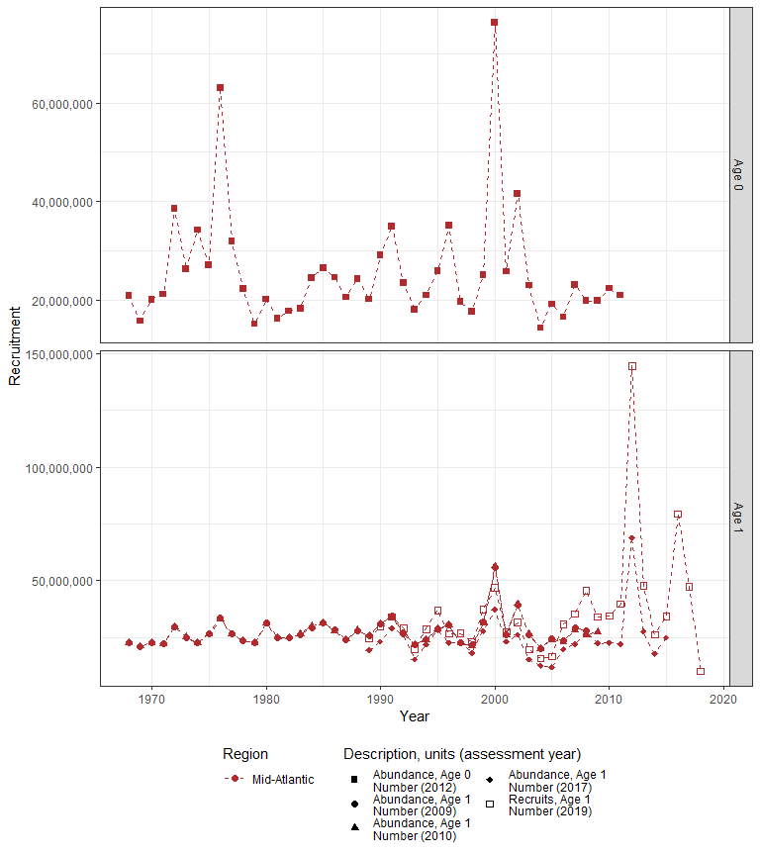

Figure 4.19: Black sea bass recruitment

#### Risk

See Methods for risk calculation details.

##### Rank of change compared to historical, ranked among stocks

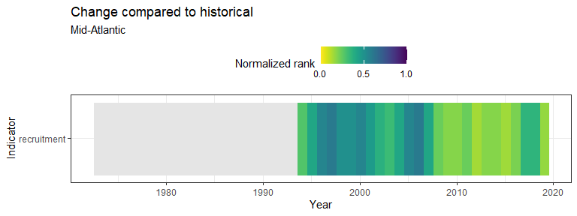

Figure 4.20: Black sea bass rank of change in indicator compared to historical, ranked among stocks

##### Rank of value (magnitude) in each year, compared to other stocks

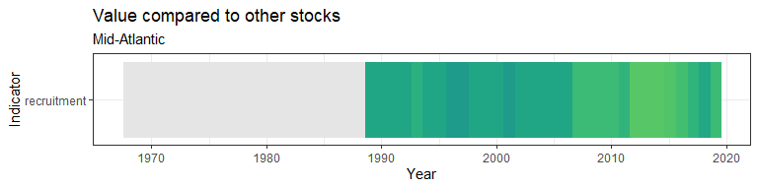

Figure 4.21: Black sea bass rank of value (magnitude) in each year, compared to other stocks

##### Rank of value (magnitude) within a single stock, compared to all years

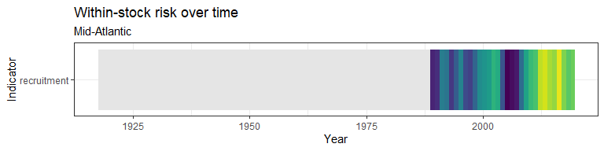

Figure 4.22: Black sea bass rank of value (magnitude) within a single stock, compared to all years

### 4.4.2 Data

## [1] "More than 60 rows of data! Please see `data` folder."

## 4.5 Age diversity

Diversity in age measurements of a stock is a useful indicator of several factors relating to fishing pressure and recruitment. A decrease in diversity can be due to either truncation, the lack of older or younger ages. Diversity changes as a function of an increase of a single/few ages relative to the usual stock age structure or as more ages become less represented. Diagnostic plots of age are constructed below using fisheries independent data from survdat.

### 4.5.1 Age diversity

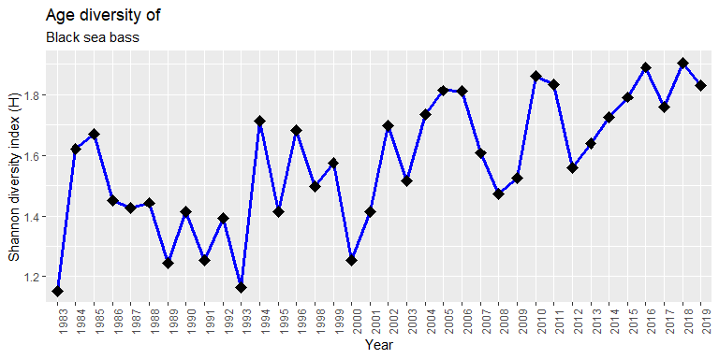

Figure 4.23: Black sea bass age diversity

### 4.5.2 Density plots of age

Age distribution across years of survey data of Black sea bass. These plots can help identify strong year classes of recruits and how these classes persist in the fishery.

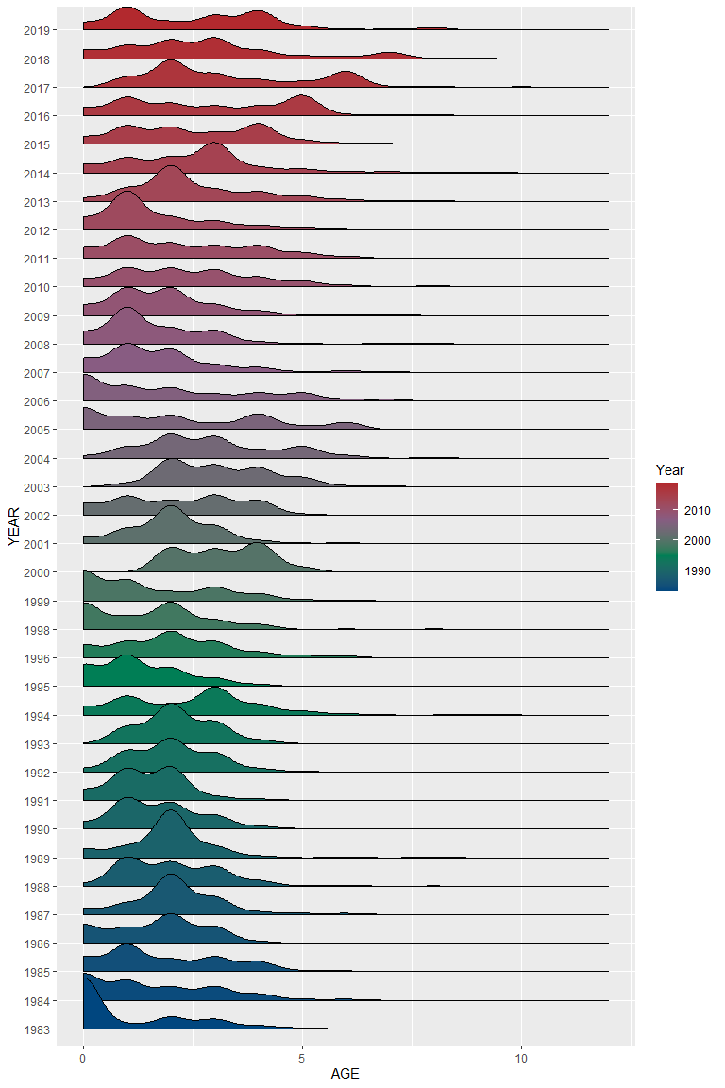

Figure 4.24: Black sea bass age density

## 4.6 Climate vulnerability

Climate vulnerability is sourced from Hare et al. (2016). The overall climate score for Black sea bass was with certainty.

### 4.6.1 Figures

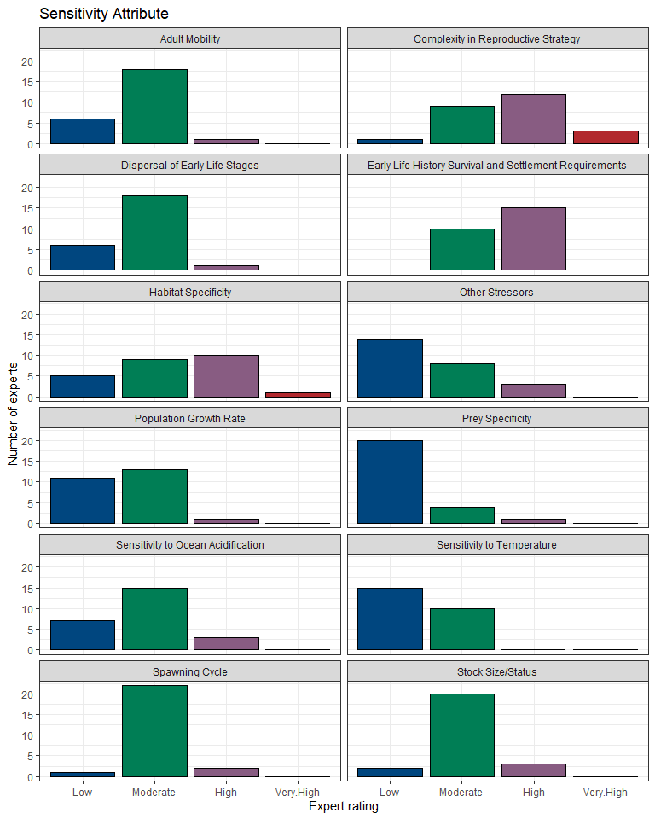

Figure 4.25: Black sea bass climate vulnerability

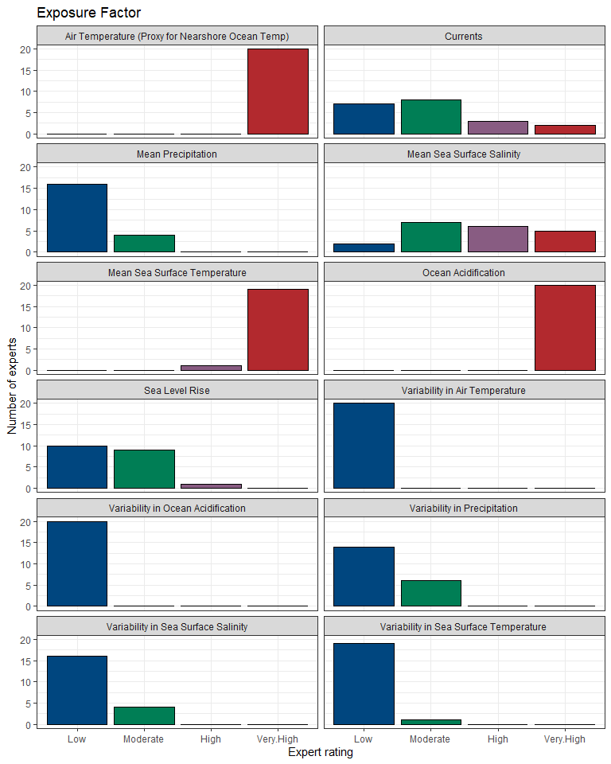

Figure 4.26: Black sea bass climate vulnerability

### 4.6.2 Data

|  |  |  |  |  |  |  |
| --- | --- | --- | --- | --- | --- | --- |
| Functional group | Attribute | Attribute category | Expert score: low | Expert score: moderate | Expert score: high | Expert score: very high |
| Coastal Fish | Adult Mobility | Sensitivity Attribute | 6 | 18 | 1 | 0 |
| Coastal Fish | Air Temperature (Proxy for Nearshore Ocean Temp) | Exposure Factor | 0 | 0 | 0 | 20 |
| Coastal Fish | Complexity in Reproductive Strategy | Sensitivity Attribute | 1 | 9 | 12 | 3 |
| Coastal Fish | Currents | Exposure Factor | 7 | 8 | 3 | 2 |
| Coastal Fish | Dispersal of Early Life Stages | Sensitivity Attribute | 6 | 18 | 1 | 0 |
| Coastal Fish | Early Life History Survival and Settlement Requirements | Sensitivity Attribute | 0 | 10 | 15 | 0 |
| Coastal Fish | Habitat Specificity | Sensitivity Attribute | 5 | 9 | 10 | 1 |
| Coastal Fish | Mean Precipitation | Exposure Factor | 16 | 4 | 0 | 0 |
| Coastal Fish | Mean Sea Surface Salinity | Exposure Factor | 2 | 7 | 6 | 5 |
| Coastal Fish | Mean Sea Surface Temperature | Exposure Factor | 0 | 0 | 1 | 19 |
| Coastal Fish | Ocean Acidification | Exposure Factor | 0 | 0 | 0 | 20 |
| Coastal Fish | Other Stressors | Sensitivity Attribute | 14 | 8 | 3 | 0 |
| Coastal Fish | Population Growth Rate | Sensitivity Attribute | 11 | 13 | 1 | 0 |
| Coastal Fish | Prey Specificity | Sensitivity Attribute | 20 | 4 | 1 | 0 |
| Coastal Fish | Sea Level Rise | Exposure Factor | 10 | 9 | 1 | 0 |
| Coastal Fish | Sensitivity to Ocean Acidification | Sensitivity Attribute | 7 | 15 | 3 | 0 |
| Coastal Fish | Sensitivity to Temperature | Sensitivity Attribute | 15 | 10 | 0 | 0 |
| Coastal Fish | Spawning Cycle | Sensitivity Attribute | 1 | 22 | 2 | 0 |
| Coastal Fish | Stock Size/Status | Sensitivity Attribute | 2 | 20 | 3 | 0 |
| Coastal Fish | Variability in Air Temperature | Exposure Factor | 20 | 0 | 0 | 0 |
| Coastal Fish | Variability in Ocean Acidification | Exposure Factor | 20 | 0 | 0 | 0 |
| Coastal Fish | Variability in Precipitation | Exposure Factor | 14 | 6 | 0 | 0 |
| Coastal Fish | Variability in Sea Surface Salinity | Exposure Factor | 16 | 4 | 0 | 0 |
| Coastal Fish | Variability in Sea Surface Temperature | Exposure Factor | 19 | 1 | 0 | 0 |

# 5 Socio-economic information

## 5.1 Catch

Stock assessment catch data are from assessmentdata::stockAssessmentData. Recreational catch data were downloaded from [NOAA MRIP](https://www.st.nmfs.noaa.gov/st1/recreational/MRIP_Estimate_Data/CSV/). Commercial catch data were downloaded from [NOAA FOSS](https://foss.nmfs.noaa.gov/apexfoss/f?p=215:200:4615327020711::NO:::).

### 5.1.1 Stock assessment catch

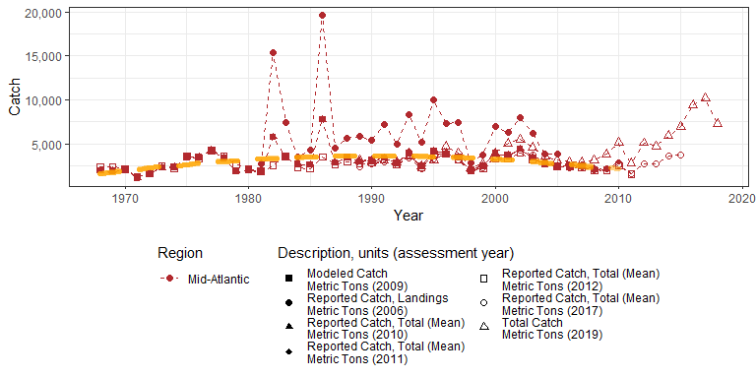

Figure 5.1: Black sea bass assessment catch

#### Risk

See Methods for risk calculation details.

##### Rank of change compared to historical, ranked among stocks

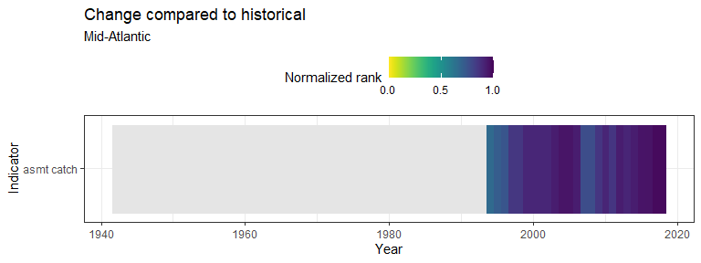

Figure 5.2: Black sea bass rank of change in indicator compared to historical, ranked among stocks

##### Rank of value (magnitude) in each year, compared to other stocks

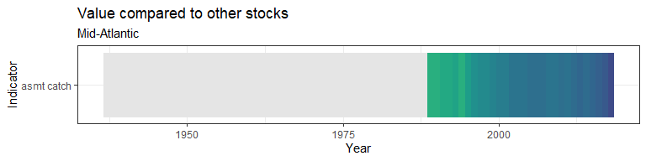

Figure 5.3: Black sea bass rank of value (magnitude) in each year, compared to other stocks

##### Rank of value (magnitude) within a single stock, compared to all years

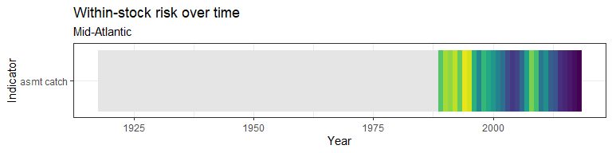

Figure 5.4: Black sea bass rank of value (magnitude) within a single stock, compared to all years

### 5.1.2 Recreational catch

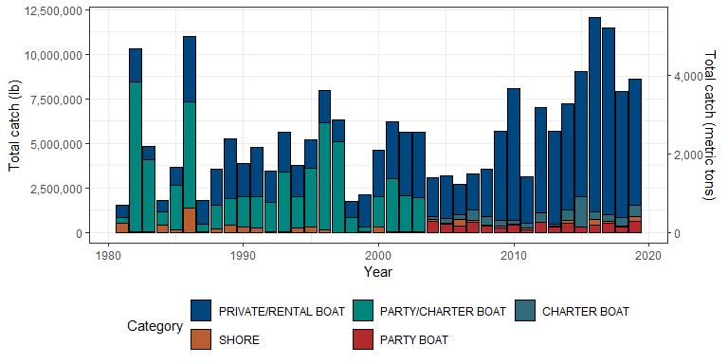

Figure 5.5: Black sea bass recreational catch

#### Risk

See Methods for risk calculation details.

##### Rank of change compared to historical, ranked among stocks

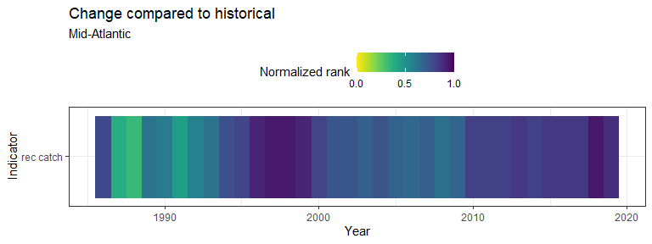

Figure 5.6: Black sea bass rank of change in indicator compared to historical, ranked among stocks

##### Rank of value (magnitude) in each year, compared to other stocks

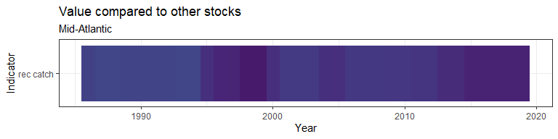

Figure 5.7: Black sea bass rank of value (magnitude) in each year, compared to other stocks

##### Rank of value (magnitude) within a single stock, compared to all years

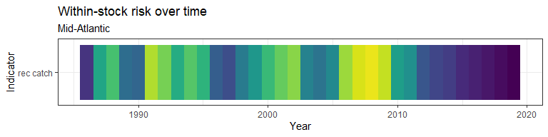

Figure 5.8: Black sea bass rank of value (magnitude) within a single stock, compared to all years

### 5.1.3 Commercial catch

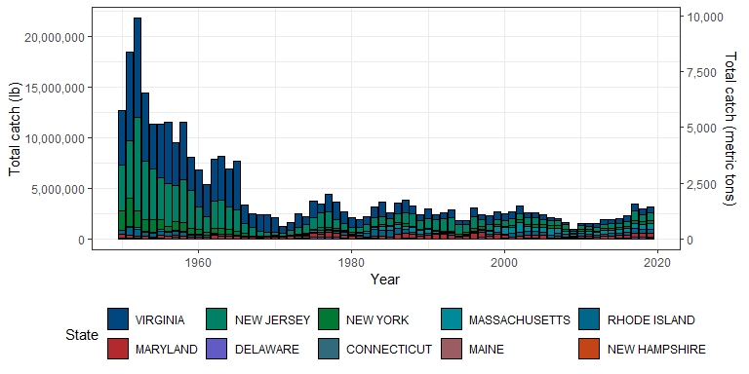

Figure 5.9: Black sea bass commercial catch

#### Risk

See Methods for risk calculation details.

##### Rank of change compared to historical, ranked among stocks

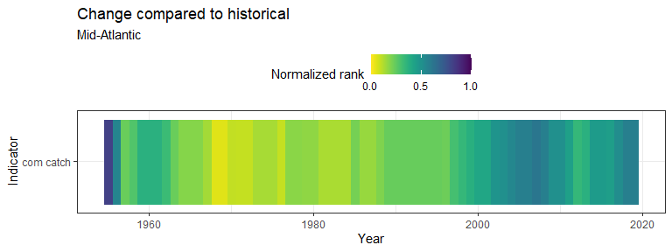

Figure 5.10: Black sea bass rank of change in indicator compared to historical, ranked among stocks

##### Rank of value (magnitude) in each year, compared to other stocks

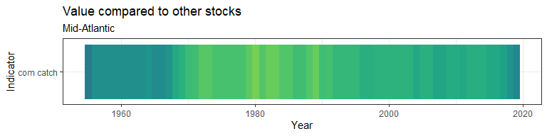

Figure 5.11: Black sea bass rank of value (magnitude) in each year, compared to other stocks

##### Rank of value (magnitude) within a single stock, compared to all years

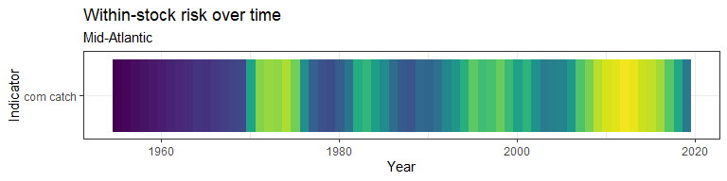

Figure 5.12: Black sea bass rank of value (magnitude) within a single stock, compared to all years

### 5.1.4 Commercial vs recreational catch

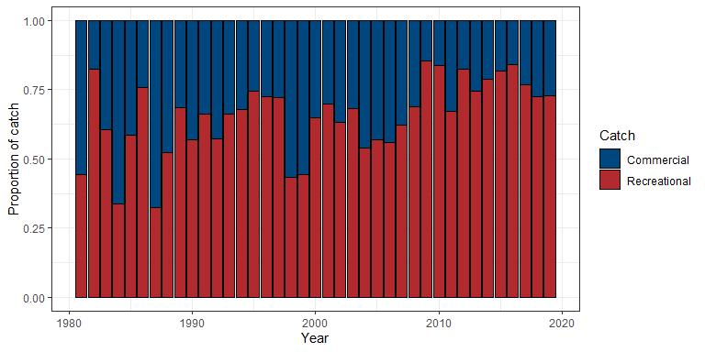

Figure 5.13: Black sea bass proportional commercial and recreational catch

### 5.1.5 Data

#### 5.1.5.1 Stock assessment catch

## [1] "More than 60 rows of data! Please see `data` folder."

#### 5.1.5.2 Recreational catch

## [1] "More than 60 rows of data! Please see `data` folder."

#### 5.1.5.3 Commercial catch

## [1] "More than 60 rows of data! Please see `data` folder."

#### 5.1.5.4 Commercial vs recreational catch

|  |  |  |  |  |  |
| --- | --- | --- | --- | --- | --- |
| Year | Recreational catch | Commercial catch | Total catch | Proportion recreational | Proportion commercial |
| 1981 | 1,534,593 | 1,914,200 | 3,448,793 | 0.445 | 0.555 |
| 1982 | 10,301,095 | 2,212,800 | 12,513,895 | 0.823 | 0.177 |
| 1983 | 4,832,832 | 3,167,100 | 7,999,932 | 0.604 | 0.396 |
| 1984 | 1,830,783 | 3,618,400 | 5,449,183 | 0.336 | 0.664 |
| 1985 | 3,653,820 | 2,597,038 | 6,250,858 | 0.585 | 0.415 |
| 1986 | 11,012,899 | 3,515,100 | 14,527,999 | 0.758 | 0.242 |
| 1987 | 1,820,214 | 3,811,500 | 5,631,714 | 0.323 | 0.677 |
| 1988 | 3,580,857 | 3,247,500 | 6,828,357 | 0.524 | 0.476 |
| 1989 | 5,266,254 | 2,436,100 | 7,702,354 | 0.684 | 0.316 |
| 1990 | 3,885,803 | 2,940,273 | 6,826,076 | 0.569 | 0.431 |
| 1991 | 4,759,469 | 2,433,242 | 7,192,711 | 0.662 | 0.338 |
| 1992 | 3,469,392 | 2,593,775 | 6,063,167 | 0.572 | 0.428 |
| 1993 | 5,649,089 | 2,896,202 | 8,545,291 | 0.661 | 0.339 |
| 1994 | 3,788,440 | 1,800,261 | 5,588,701 | 0.678 | 0.322 |
| 1995 | 5,217,240 | 1,794,154 | 7,011,394 | 0.744 | 0.256 |
| 1996 | 7,947,105 | 3,030,753 | 10,977,858 | 0.724 | 0.276 |
| 1997 | 6,315,411 | 2,419,927 | 8,735,338 | 0.723 | 0.277 |
| 1998 | 1,745,416 | 2,269,017 | 4,014,433 | 0.435 | 0.565 |
| 1999 | 2,112,664 | 2,650,478 | 4,763,142 | 0.444 | 0.556 |
| 2000 | 4,633,982 | 2,514,369 | 7,148,351 | 0.648 | 0.352 |
| 2001 | 6,234,605 | 2,699,013 | 8,933,618 | 0.698 | 0.302 |
| 2002 | 5,653,822 | 3,304,771 | 8,958,593 | 0.631 | 0.369 |
| 2003 | 5,650,181 | 2,618,711 | 8,268,892 | 0.683 | 0.317 |
| 2004 | 3,086,942 | 2,628,284 | 5,715,226 | 0.540 | 0.460 |
| 2005 | 3,200,063 | 2,417,806 | 5,617,869 | 0.570 | 0.430 |
| 2006 | 2,709,915 | 2,145,281 | 4,855,196 | 0.558 | 0.442 |
| 2007 | 3,280,316 | 1,997,558 | 5,277,874 | 0.622 | 0.378 |
| 2008 | 3,559,283 | 1,623,615 | 5,182,898 | 0.687 | 0.313 |
| 2009 | 5,690,344 | 961,423 | 6,651,767 | 0.855 | 0.145 |
| 2010 | 8,049,598 | 1,577,042 | 9,626,640 | 0.836 | 0.164 |
| 2011 | 3,159,142 | 1,539,253 | 4,698,395 | 0.672 | 0.328 |
| 2012 | 7,031,921 | 1,514,900 | 8,546,821 | 0.823 | 0.177 |
| 2013 | 5,668,032 | 1,949,085 | 7,617,117 | 0.744 | 0.256 |
| 2014 | 7,239,604 | 1,958,395 | 9,197,999 | 0.787 | 0.213 |
| 2015 | 9,050,559 | 2,000,739 | 11,051,298 | 0.819 | 0.181 |
| 2016 | 12,046,148 | 2,309,583 | 14,355,731 | 0.839 | 0.161 |
| 2017 | 11,467,594 | 3,498,803 | 14,966,397 | 0.766 | 0.234 |
| 2018 | 7,910,945 | 3,019,779 | 10,930,724 | 0.724 | 0.276 |
| 2019 | 8,601,182 | 3,194,872 | 11,796,054 | 0.729 | 0.271 |

#### 5.1.5.5 Commercial, recreational, and stock assessment catch

|  |  |  |  |  |  |
| --- | --- | --- | --- | --- | --- |
| Year | tot_catch_rec | tot_catch_com | total_catch | prop_rec | prop_com |
| 1981 | 1,534,593 | 1,914,200 | 3,448,793 | 0.445 | 0.555 |
| 1982 | 10,301,095 | 2,212,800 | 12,513,895 | 0.823 | 0.177 |
| 1983 | 4,832,832 | 3,167,100 | 7,999,932 | 0.604 | 0.396 |
| 1984 | 1,830,783 | 3,618,400 | 5,449,183 | 0.336 | 0.664 |
| 1985 | 3,653,820 | 2,597,038 | 6,250,858 | 0.585 | 0.415 |
| 1986 | 11,012,899 | 3,515,100 | 14,527,999 | 0.758 | 0.242 |
| 1987 | 1,820,214 | 3,811,500 | 5,631,714 | 0.323 | 0.677 |
| 1988 | 3,580,857 | 3,247,500 | 6,828,357 | 0.524 | 0.476 |
| 1989 | 5,266,254 | 2,436,100 | 7,702,354 | 0.684 | 0.316 |
| 1990 | 3,885,803 | 2,940,273 | 6,826,076 | 0.569 | 0.431 |
| 1991 | 4,759,469 | 2,433,242 | 7,192,711 | 0.662 | 0.338 |
| 1992 | 3,469,392 | 2,593,775 | 6,063,167 | 0.572 | 0.428 |
| 1993 | 5,649,089 | 2,896,202 | 8,545,291 | 0.661 | 0.339 |
| 1994 | 3,788,440 | 1,800,261 | 5,588,701 | 0.678 | 0.322 |
| 1995 | 5,217,240 | 1,794,154 | 7,011,394 | 0.744 | 0.256 |
| 1996 | 7,947,105 | 3,030,753 | 10,977,858 | 0.724 | 0.276 |
| 1997 | 6,315,411 | 2,419,927 | 8,735,338 | 0.723 | 0.277 |
| 1998 | 1,745,416 | 2,269,017 | 4,014,433 | 0.435 | 0.565 |
| 1999 | 2,112,664 | 2,650,478 | 4,763,142 | 0.444 | 0.556 |
| 2000 | 4,633,982 | 2,514,369 | 7,148,351 | 0.648 | 0.352 |
| 2001 | 6,234,605 | 2,699,013 | 8,933,618 | 0.698 | 0.302 |
| 2002 | 5,653,822 | 3,304,771 | 8,958,593 | 0.631 | 0.369 |
| 2003 | 5,650,181 | 2,618,711 | 8,268,892 | 0.683 | 0.317 |
| 2004 | 3,086,942 | 2,628,284 | 5,715,226 | 0.540 | 0.460 |
| 2005 | 3,200,063 | 2,417,806 | 5,617,869 | 0.570 | 0.430 |
| 2006 | 2,709,915 | 2,145,281 | 4,855,196 | 0.558 | 0.442 |
| 2007 | 3,280,316 | 1,997,558 | 5,277,874 | 0.622 | 0.378 |
| 2008 | 3,559,283 | 1,623,615 | 5,182,898 | 0.687 | 0.313 |
| 2009 | 5,690,344 | 961,423 | 6,651,767 | 0.855 | 0.145 |
| 2010 | 8,049,598 | 1,577,042 | 9,626,640 | 0.836 | 0.164 |
| 2011 | 3,159,142 | 1,539,253 | 4,698,395 | 0.672 | 0.328 |
| 2012 | 7,031,921 | 1,514,900 | 8,546,821 | 0.823 | 0.177 |
| 2013 | 5,668,032 | 1,949,085 | 7,617,117 | 0.744 | 0.256 |
| 2014 | 7,239,604 | 1,958,395 | 9,197,999 | 0.787 | 0.213 |
| 2015 | 9,050,559 | 2,000,739 | 11,051,298 | 0.819 | 0.181 |
| 2016 | 12,046,148 | 2,309,583 | 14,355,731 | 0.839 | 0.161 |
| 2017 | 11,467,594 | 3,498,803 | 14,966,397 | 0.766 | 0.234 |
| 2018 | 7,910,945 | 3,019,779 | 10,930,724 | 0.724 | 0.276 |
| 2019 | 8,601,182 | 3,194,872 | 11,796,054 | 0.729 | 0.271 |

## 5.2 F/Fmsy

F/Fmsy data were pulled from assessmentdata::stockAssessmentSummary.

The most recent status of F/Fmsy is: GOOD

### 5.2.1 Figure

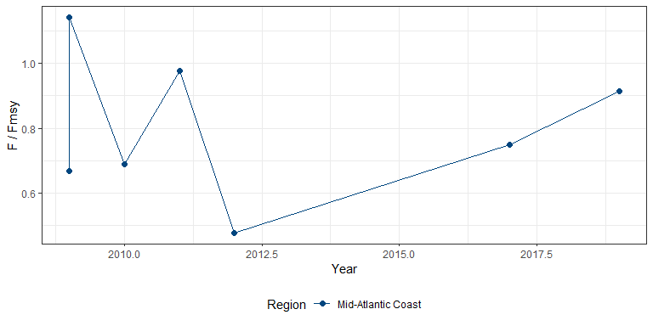

Figure 5.14: Black sea bass F/Fmsy

#### Risk

See Methods for risk calculation details.

##### Rank of change compared to historical, ranked among stocks

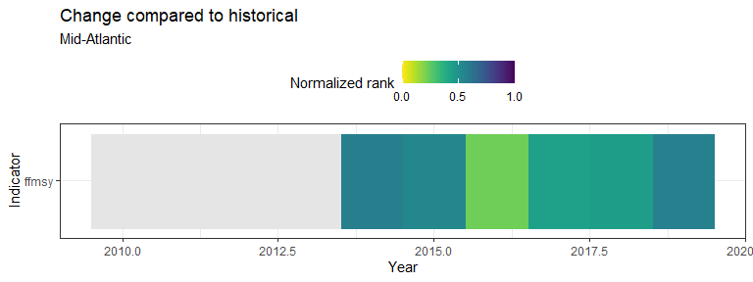

Figure 5.15: Black sea bass rank of change in indicator compared to historical, ranked among stocks

##### Rank of value (magnitude) in each year, compared to other stocks

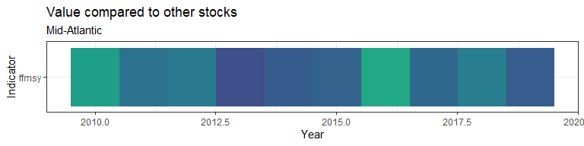

Figure 5.16: Black sea bass rank of value (magnitude) in each year, compared to other stocks

##### Rank of value (magnitude) within a single stock, compared to all years

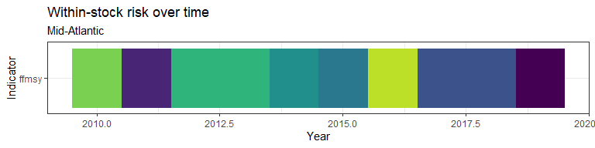

Figure 5.17: Black sea bass rank of value (magnitude) within a single stock, compared to all years

### 5.2.2 Data

|  |  |  |
| --- | --- | --- |
| Region | Year | F/Fmsy |
| Mid-Atlantic Coast | 2009 | 0.67 |
| Mid-Atlantic Coast | 2009 | 1.14 |
| Mid-Atlantic Coast | 2010 | 0.69 |
| Mid-Atlantic Coast | 2011 | 0.98 |
| Mid-Atlantic Coast | 2012 | 0.48 |
| Mid-Atlantic Coast | 2017 | 0.75 |
| Mid-Atlantic Coast | 2019 | 0.91 |

## 5.3 Revenue

Commercial catch data were downloaded from [NOAA FOSS](https://foss.nmfs.noaa.gov/apexfoss/f?p=215:200:4615327020711::NO:::).

### 5.3.1 Figure

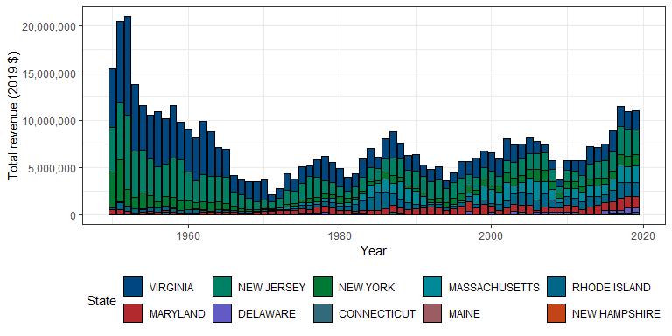

Figure 5.18: Black sea bass revenue

#### Risk

See Methods for risk calculation details.

##### Rank of change compared to historical, ranked among stocks

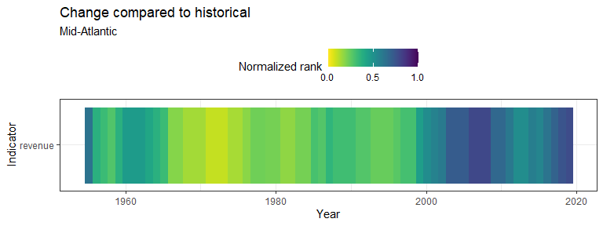

Figure 5.19: Black sea bass rank of change in indicator compared to historical, ranked among stocks

##### Rank of value (magnitude) in each year, compared to other stocks

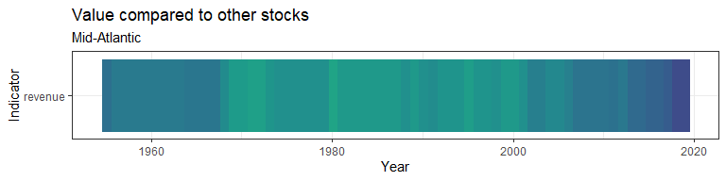

Figure 5.20: Black sea bass rank of value (magnitude) in each year, compared to other stocks

##### Rank of value (magnitude) within a single stock, compared to all years

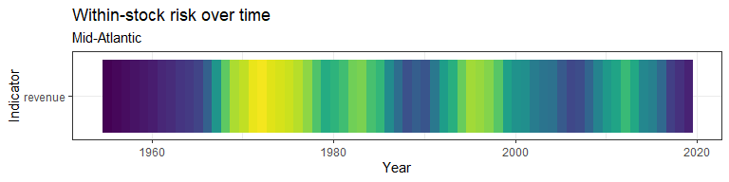

Figure 5.21: Black sea bass rank of value (magnitude) within a single stock, compared to all years

### 5.3.2 Data

## [1] "More than 60 rows of data! Please see `data` folder."

# 6 Management information

## 6.1 Stock assessment and data quality information

Stock assessment and data quality information were pulled from assessmentdata::stockAssessmentSummary.

|  |  |  |  |  |  |  |  |  |  |
| --- | --- | --- | --- | --- | --- | --- | --- | --- | --- |
| Species | Region | Assessment Year | Last Data Year | Biological Data Rating (2019) | Biological Data Rating (before 2019) | Size Data Rating | Ecosystem Linkage Data Rating | FSSI status | Review Result |
| Black sea bass | Mid-Atlantic Coast | 2006 | 2006 | NA | 2 | NA | NA | Y | Partial acceptance - Biomass estimates |
| Black sea bass | Mid-Atlantic Coast | 2009 | 2008 | NA | 2 | NA | NA | Y | Full acceptance |
| Black sea bass | Mid-Atlantic Coast | 2009 | 2007 | NA | 2 | NA | NA | Y | Full acceptance |
| Black sea bass | Mid-Atlantic Coast | 2010 | 2009 | NA | 2 | NA | NA | Y | Full acceptance |
| Black sea bass | Mid-Atlantic Coast | 2011 | 2010 | NA | 2 | NA | NA | Y | Accept previous approach, remand new attempt |
| Black sea bass | Mid-Atlantic Coast | 2012 | 2011 | NA | 2 | NA | NA | Y | Full acceptance |
| Black sea bass | Mid-Atlantic Coast | 2017 | 2015 | NA | 2 | NA | NA | Y | Full acceptance |
| Black sea bass | Mid-Atlantic Coast | 2019 | 2018 | NA | NA | 4 | 1 | Y | Full acceptance |

# 7 Risk assessment

A preliminary risk analysis was conducted by ranking all species according to their indicator values. A high rank number and a normalized rank near 1 indicates that the species is at risk or of importance based on the measured indicator values. When a species was missing an indicator, it was assigned a normalized rank of 0.5.

## 7.1 Figures

### 7.1.1 Relative to all other stocks

Risk was calculated over time for all indicators that were documented for five or more species in a given year. Risk was calculated as the average of the past 5 years, as a percent of the historical average. The normalized risk value plotted here reflects the normalized rank of this stock compared to all other stocks in that year.

#### Comprehensive risk assessment

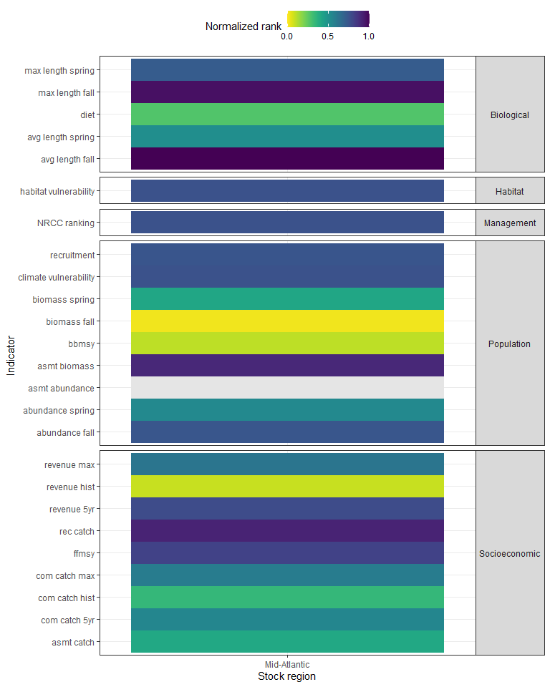

Figure 7.1: Black sea bass comprehensive risk assessment

#### Normalized rank of magnitude of change compared to historical value by year

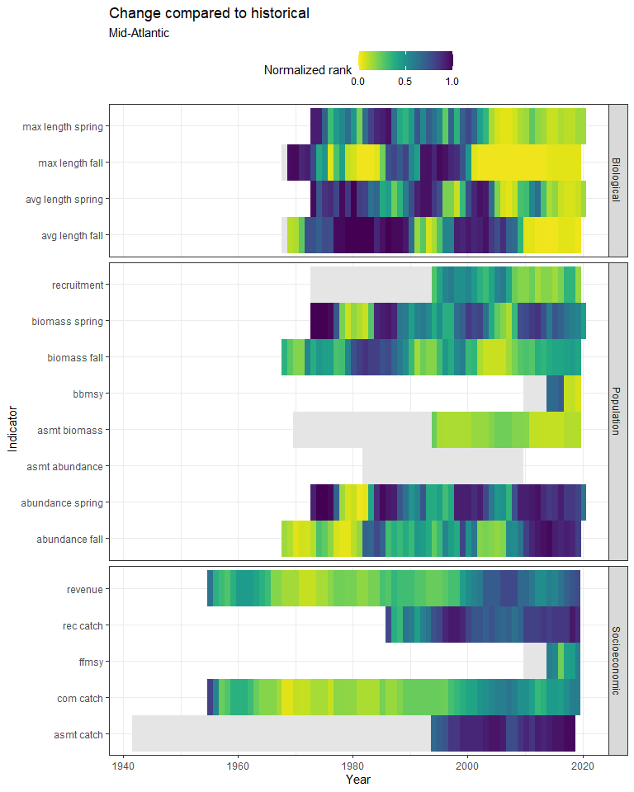

Figure 7.2: Black sea bass normalized rank of magnitude of change compared to historical value by year

#### Normalized rank of value in each year

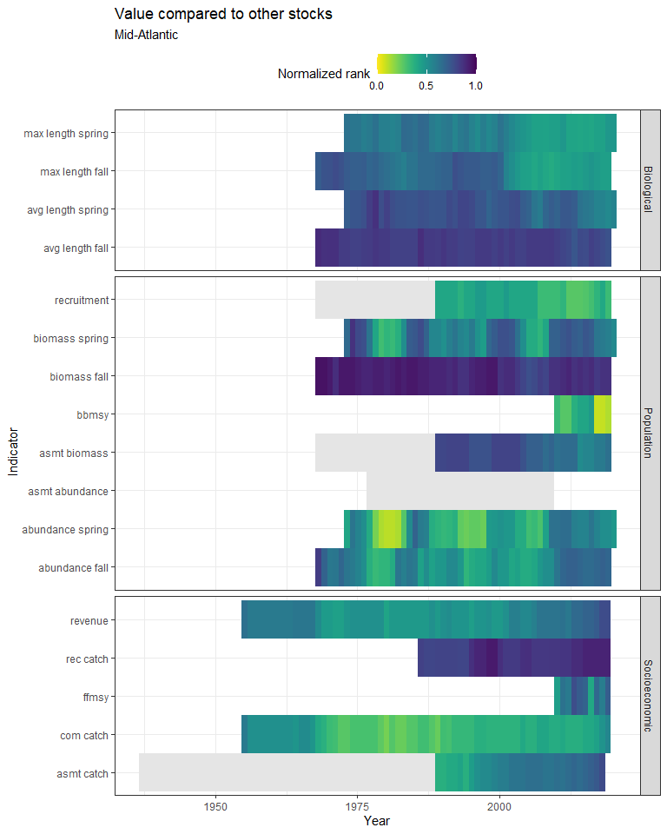

Figure 7.3: Black sea bass normalized rank of value in each year

### 7.1.2 Within a single stock

For each stock, a five-year running mean was calculated for each indicator. Indicator values were then ranked for all years where a value was present. The normalized risk values plotted here reflects the normalized rank of each year compared to all other years.

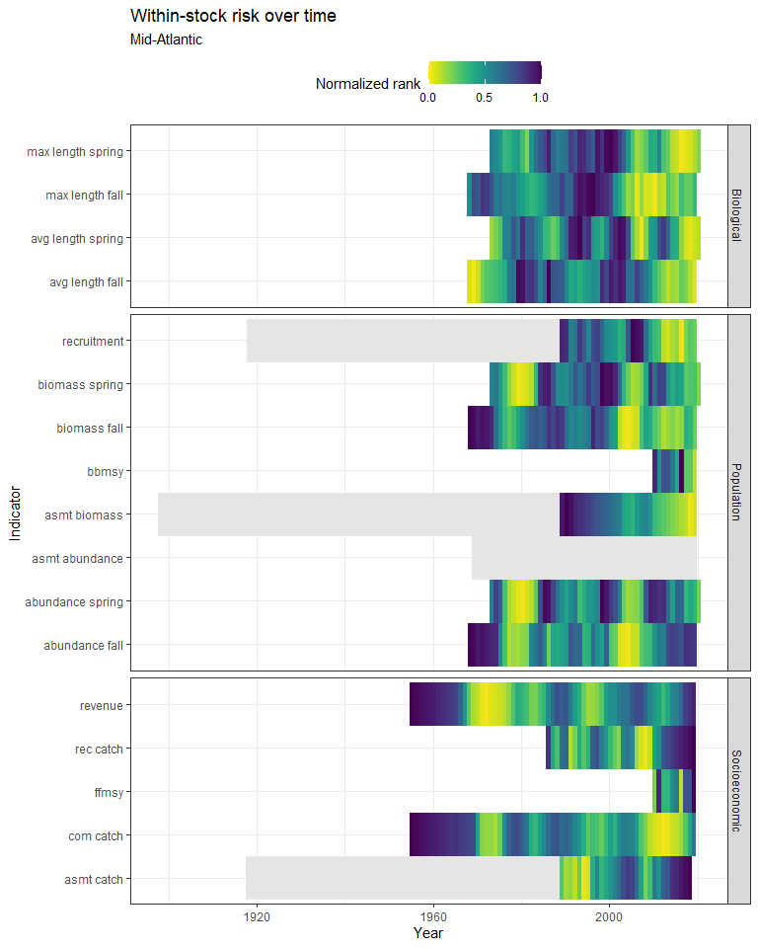

Figure 7.4: Black sea bass within-stock risk over time

## 7.2 Data

### 7.2.1 Relative to all other stocks

#### Comprehensive risk assessment

|  |  |  |  |  |  |  |  |  |  |  |  |
| --- | --- | --- | --- | --- | --- | --- | --- | --- | --- | --- | --- |
| Species | Region | Indicator | category | Year | Value | rank | n_stocks_per_indicator | norm_rank | total_risk | overall_rank | overall_stocks |
| Black sea bass | Mid-Atlantic | bbmsy | Population | 2019 | 2.3710 | 4 | 41 | 0.0976 | 14.66 | 44 | 55 |
| Black sea bass | Mid-Atlantic | ffmsy | Socioeconomic | 2019 | 0.9130 | 29 | 36 | 0.8056 | 14.66 | 44 | 55 |
| Black sea bass | Mid-Atlantic | asmt_catch | Socioeconomic | 2017 | 10,162.0000 | 16 | 40 | 0.4000 | 14.66 | 44 | 55 |
| Black sea bass | Mid-Atlantic | recruitment | Population | mean of 2009 - 2019 | 0.7458 | 17 | 23 | 0.7391 | 14.66 | 44 | 55 |
| Black sea bass | Mid-Atlantic | asmt_abundance | Population | NA | NA | NA | NA | NA | 14.66 | 44 | 55 |
| Black sea bass | Mid-Atlantic | asmt_biomass | Population | mean of 2009 - 2019 | 3.0928 | 32 | 36 | 0.8889 | 14.66 | 44 | 55 |
| Black sea bass | Mid-Atlantic | biomass_fall | Population | mean of 2009 - 2019 | 0.0029 | 1 | 49 | 0.0204 | 14.66 | 44 | 55 |
| Black sea bass | Mid-Atlantic | biomass_spring | Population | magnitude of % change, magnitude of % change, mean of 2009 - 2019 vs historic vs historic | 0.4068 | 20 | 49 | 0.4082 | 14.66 | 44 | 55 |
| Black sea bass | Mid-Atlantic | abundance_fall | Population | mean of 2009 - 2019 | 0.6546 | 36 | 49 | 0.7347 | 14.66 | 44 | 55 |
| Black sea bass | Mid-Atlantic | abundance_spring | Population | magnitude of % change, magnitude of % change, mean of 2009 - 2019 vs historic vs historic | 0.5608 | 26 | 49 | 0.5306 | 14.66 | 44 | 55 |
| Black sea bass | Mid-Atlantic | avg_length_fall | Biological | mean of 2009 - 2019 | 0.4371 | 49 | 49 | 1.0000 | 14.66 | 44 | 55 |
| Black sea bass | Mid-Atlantic | avg_length_spring | Biological | magnitude of % change, magnitude of % change, mean of 2009 - 2019 vs historic vs historic | 0.0835 | 25 | 49 | 0.5102 | 14.66 | 44 | 55 |
| Black sea bass | Mid-Atlantic | max_length_fall | Biological | mean of 2009 - 2019 | 0.1983 | 47 | 49 | 0.9592 | 14.66 | 44 | 55 |
| Black sea bass | Mid-Atlantic | max_length_spring | Biological | magnitude of % change, magnitude of % change, mean of 2009 - 2019 vs historic vs historic | 0.1253 | 35 | 49 | 0.7143 | 14.66 | 44 | 55 |
| Black sea bass | Mid-Atlantic | NRCC_ranking | Management | NRCC_risk_assessment | 37.0000 | 33 | 43 | 0.7500 | 14.66 | 44 | 55 |
| Black sea bass | Mid-Atlantic | diet | Biological | all time | 13.0000 | 3 | 45 | 0.2727 | 14.66 | 44 | 55 |
| Black sea bass | Mid-Atlantic | rec_catch | Socioeconomic | mean of 2014 - 2019 | 9,815,285.6000 | 29 | 38 | 0.9062 | 14.66 | 44 | 55 |
| Black sea bass | Mid-Atlantic | com_catch_max | Socioeconomic | 1952 | 21,787,600.0000 | 21 | 54 | 0.5833 | 14.66 | 44 | 55 |
| Black sea bass | Mid-Atlantic | com_catch_5yr | Socioeconomic | mean of 2014 - 2019 | 2,804,755.2000 | 19 | 53 | 0.5429 | 14.66 | 44 | 55 |
| Black sea bass | Mid-Atlantic | com_catch_hist | Socioeconomic | mean of 2009 - 2019 | 0.5303 | 12 | 52 | 0.3333 | 14.66 | 44 | 55 |
| Black sea bass | Mid-Atlantic | revenue_max | Socioeconomic | 1952 | 20,964,384.7445 | 22 | 54 | 0.6111 | 14.66 | 44 | 55 |
| Black sea bass | Mid-Atlantic | revenue_5yr | Socioeconomic | mean of 2014 - 2019 | 9,953,771.3334 | 27 | 53 | 0.7714 | 14.66 | 44 | 55 |
| Black sea bass | Mid-Atlantic | revenue_hist | Socioeconomic | mean of 2009 - 2019 | 0.1372 | 3 | 52 | 0.0833 | 14.66 | 44 | 55 |
| Black sea bass | Mid-Atlantic | climate_vulnerability | Population | Hare et al. 2016 | 3.0000 | 3 (dense rank) | 52 | 0.7500 | 14.66 | 44 | 55 |
| Black sea bass | Mid-Atlantic | habitat_vulnerability | Habitat | ecodata | 3.0000 | 3 (dense rank) | 17 | 0.7500 | 14.66 | 44 | 55 |

#### Normalized rank of magnitude of change compared to historical value by year

## [1] "More than 60 rows of data! Please see `data` folder."

#### Normalized rank of value in each year

## [1] "More than 60 rows of data! Please see `data` folder."

### 7.2.2 Value within each stock, ranked by year

## [1] "More than 60 rows of data! Please see `data` folder."